|  |  |
| --- | --- |
|  |  |
|  |
|  |
|  |
|  |

|  |
| --- |
|  |
|  |
| / |
|  |
|  |

Table of Contents

4 Specification of Supply and Services 6

4.1 Process Equipment 6

CB.1. Ladle transportation 6

CB.2. Casting machine 7

CB.21. Ladle turret 7

CB.21.1A Ladle turret butterfly 7

CB.21.2 Ladle 10

CB.21.3 Ladle cover 10

CB.21.4 Ladle slide gate equipment 10

CB.21.5 Manipulators 11

CB.21.51 Ladle cover manipulator 11

CB.21.52 Ladle slide gate cylinder assembly device 12

CB.22. Tundish facility 13

CB.22.1A Tundish car semi gantry 1-strand 13

CB.22.2 Tundish 16

CB.22.3 Tundish cover 18

CB.22.4 Tundish stopper control 19

CB.22.51B SEN changing device 21

CB.23. Casting subsystem 23

CB.23.1 Preheating stations 23

CB.23.11 Tundish preheating station 23

CB.23.12 SEN preheating device 24

CB.23.2 Manipulators 25

CB.23.22 Ladle shroud manipulator manual 25

CB.23.6 Pulpits 27

CB.23.61 Pulpit OS1 27

CB.24. Support structure 28

CB.24.1 Machine supporting structure 28

CB.24.2 Cooling chamber 30

CB.24.3 Steam exhaust system 31

CB.24.4 Emergency casting system 32

CB.25. Smart Machine head 33

CB.25.1 Smart Mold 34

CB.25.5 Mold subsystem 38

CB.25.6 Mold cover 38

CB.25.7 Mold fume exhaust system 39

CB.25.8 DynaFlex Oscillator 40

CB.25.9 Oscillator support structure with bender support 43

CB.26 Strand guide 44

CB.26.1A Bender 44

CB.26.2-4 Smart Segments 47

CB.26.2A / CB.26.2B Smart Bow segment A and B 47

CB.26.3A / CB.26.3B Smart Straightener segment A and B 47

CB.26.4A Smart Horizontal segment 47

CB.26.6 Strand guide support structure 54

CB.26.9 Strand guide functions 56

CB.26.95 Smart Segments (PI) 56

CB.26.95A Smart Segments position control 56

CB.27. Withdrawal units & exchange device 64

CB.27.1 Drives for driven rollers 64

CB.27.2A Segment manipulator U-shape type (Existing) 66

CB.28 Safety devices 68

CB.3. Runout area 69

CB.31. Dummy bar facilities 69

CB.31.1 Dummy bar 69

CB.31.3 Dummy bar receiver 71

CB.31.5 Storage stand for dummy bar head 72

CB.32. Cutting- & scrap facility 73

CB.32.1 Torch cutting machine 73

CB.32.3 Emergency cutting equipment 75

CB.32.31 Hand torch cutter 75

CB.32.5 Crop and Scrap removal system 76

CB.33. Roller tables 77

CB.33.1 Torch approach roller table 78

CB.33.2A Torch cutting roller table 79

CB.33.3 Runout roller table 81

CB.33.4 Weighing roller table with weighing grid 82

CB.33.5 Discharge roller table 83

CB.34. Roller table auxiliaries 85

CB.34.2 Fixed stop 85

CB.34.5 Strand tracking systems 86

CB.35. Deburring- & marking facilities 87

CB.35.1A Rotary type deburrer 87

CB.35.2 Burr discharge chute 88

CB.35.4B Metal wire/ powder marking machine 89

CB.36. Piling & transfer facilities 90

CB.36.1A Piler pusher (Option) 90

CB.36.2A Piler table (Option) 92

CB.38 Safety devices 94

CB.4. Slab handling 95

CB.42. Inspection facilities 95

CB.42.1 Inspection grate 95

CB.42.3 Hand scarfing device (Existing) 96

CB.42.4 Hand grinding device (Existing) 96

CB.42.5 Slab turning device (Existing) 96

CB.48 Safety devices 96

CB.5. Peripheral Facilities 97

CB.51. Maintenance stands 97

CB.51.1 Alignment stands 99

CB.51.11 Mold alignment stand (Existing) 99

CB.51.12 Maintenance stand for oscillator (Existing) 102

CB.51.13 Bender alignment stand (Existing) 104

CB.51.14 Segment alignment stand for entire segment (Existing) 106

CB.51.15 Segment alignment stand for inner bow (Existing) 108

CB.51.2 Storage- and handling stands 110

CB.51.21 Storage stand for DynaFlex oscillator 110

CB.51.22 Storage stand for mold with bender 111

CB.51.23 Bender turning stand (Existing) 112

CB.51.24 Segment inner bow turning stand (Existing) 113

CB.51.3 Water test stands 114

CB.51.31 Water test stand for bender and segment (Existing) 114

CB.51.4 Assembly / disassembly stands 116

CB.51.41 Roller assembly / disassembly stand (Existing) 116

CB.52. Measuring devices 118

CB.52.1 Mold measuring devices 118

CB.52.11A Taper measuring device (Existing) 118

CB.52.12 Measuring device for foot roller-bender (Existing) 119

CB.52.13 Transition ruler foot rollers / copper plates (Existing) 120

CB.52.2 Strand guide measuring devices 121

CB.52.21 Transition rulers (Existing) 121

CB.52.22 Strand Checker (Option) 122

CB.52.23 Gap Checker – (Manual roll gap checker) (Existing) 124

CB.52.25 Roller alignment device OPAL (Existing) 125

CB.53. Tundish preparation 126

CB.53.5 Flow control maintenance devices 127

CB.53.55 Stopper rod trestle 127

CB.53.6 Tundish relining equipment 127

CB.53.7 Tundish gunning equipment 127

CB.53.9 Tundish auxiliaries & building 127

CB.54. Suspensions 128

CB.54.1 Beam suspensions 128

CB.54.11 Tundish beam suspension (Existing) 128

CB.54.12A Universal beam suspension casting area 129

CB.54.2 Rope / Chain suspensions 131

CB.54.3 Storage stands for beam suspensions 132

CB.54.4 Storage stands for rope/chain suspensions 132

CB.55. Ancillary facilities 133

CB.55.1 Standard tools 133

CB.55.2 Special tools 134

CB.55.21 Hydraulic bolt tensioning cylinder for ladle turret 134

CB.55.22 Make shifts for ladle turret 134

CB.55.23 Torque wrench for segment fixation 134

CB.55.24 Tie rode tensioning device for bender and segments 134

CB.55.3 Tools for casting operation 135

CB.55.4 Assembly device for erection 135

CB.56. Scale handling 135

CB.57. Refractory material and other consumables 135

CB. 7 Infrastructure and Auxiliaries 136

CB.71 Building and Foundation 136

1. Specification of Supply and Services
   1. Process Equipment

CB.1. Ladle transportation

Please refer to Division of Scope of Supply and Services Chapter 5

CB.2. Casting machine

CB.21. Ladle turret

CB.21.1A Ladle turret butterfly

Technical Data

|  |  |
| --- | --- |
| Type of design | "butterfly" type with 2 ladle supports individually liftable and lowerable and common turning device |
| Weight of heat | 120 t (maximum liquid steel) |
| Weight of filled ladle | 260 t (including ladle refractory, ladle skulls, slag, slide gate and ladle cover) |
| Carrying capacity (including ladle skulls, slag, slide gate and ladle cover) | 260 t / 0 t loaded on one side 260 t / 260 t loaded on both sides |
| Design capacity for ladle turret | carrying capacity plus ladle cover manipulator |
| Impact coefficient:(when depositing the ladle) | operating load case 1.2 special load case 1.3 |
| Design standard | EN 13001 |
| Load group according to | 250,000 full ladles  load collective S 3 (heavy) |
| Turning radius | approx. 5.6 m |
| Turning speed | max. 1 rpm, emergency mode min. 0.5 rpm |
| Turning angle  Normal operation Emergency mode  Position-fixing-device | unlimited in both directions 180 degree  fixing of turning parts in casting position by turning device |
| Lifting height | 800 mm |
| Lifting speed (full ladle)  Lifting control | 20 mm/s  by limit switches |
| Ladle weighing | by weighing beams |

Functional Description

The ladle turret serves for transporting the teeming ladles from the depositing position into the casting position and vice versa.

The ladle is deposited onto the turret and after turning to the casting position, the ladle shroud is positioned to the bottom of the ladle. After connecting the ladle with the shroud the ladle is lowered nearer to the tundish and ready for the casting process.

Turning of ladle arms is carried out by hydraulic motor with gear. To avoid damage of gear and hydraulic motor during ladle depositing an overload coupling is provided. In case of power failure, hydraulic fluid is supplied from emergency accumulator to allow turning of ladle turret.

A bay crane accomplishes the manipulation of the ladles to and from the turret

Main Components

* Foundation frame with foundation anchoring
* Turning device with hydraulic motor and overload coupling
* Turning bearing
* Turning frame and lever frame
* Lifting devices with hydraulic plungers and axial bearings
* Ladle arms with upper and lower lever, radial bearings and ladle support
* Weighing beams
* Rotary joint and slip ring
* Thermal and splash protection
* Walkways and ladders for maintenance work
* Assembly makeshifts
* Machine attached piping

Main Characteristics

* Ladle supports separately liftable and lowerable
* Lifting of ladle supports via hydraulic plunger with lever system
* Emergency power supply by hydraulic accumulator via hand valve
* Fixation of turning parts in casting position by motor brake via overload coupling
* Turning bearing lubrication via a central grease lubrication unit

Advantages of Design

* Well-proven concept, liftable masses minimized, depositing of ladle is accomplished without interfering with casting operation
* Low-maintenance and rigid design
* High quality standard due to specific regulations concerning material, manufacture and inspection
* Easy disassembly of lifting plunger, axial bearings and radial bearings

Reference Drawing CB.21.1.A Ladle turret butterfly

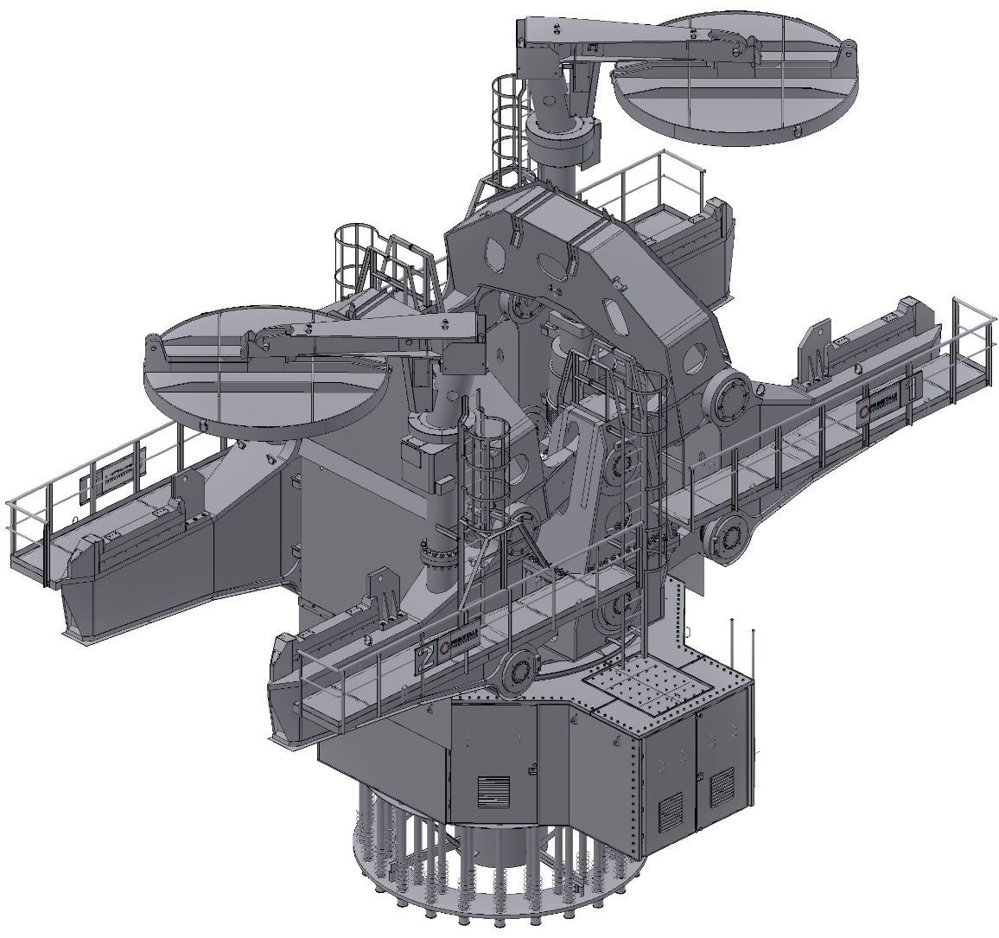

- Typical sketch for reference only –

CB.21.2 Ladle

Refer to scope of supply

CB.21.3 Ladle cover

Refer to scope of supply

Reference Drawing CB.21.3 Ladle cover

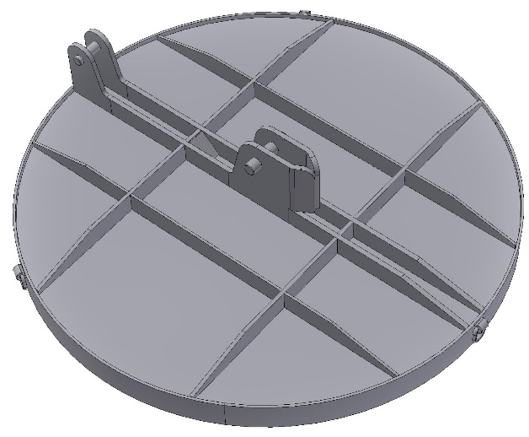

- Typical sketch for reference only -

CB.21.4 Ladle slide gate equipment

Refer to scope of supply

CB.21.5 Manipulators

CB.21.51 Ladle cover manipulator

Technical Data

|  |  |
| --- | --- |
| Type of design | jib lifting and swivelling device |
| Lifting | hydraulically |
| Turning | hydraulically |
| Carrying capacity | one ladle cover |

Functional Description

The ladle cover manipulator serves for handling the ladle cover on top of ladle.

Main Components

* Lifting structure with column in welded/bolted design
* Lifting with hydraulic lifting cylinder and turning with hydraulic gear motor device

Reference Drawing CB.21.51 Ladle cover manipulator

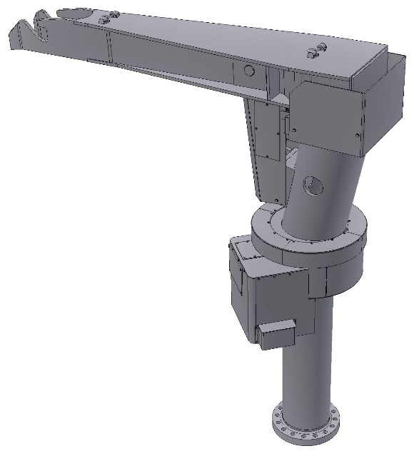

- Typical sketch for reference only -

CB.21.52 Ladle slide gate cylinder assembly device

|  |  |
| --- | --- |
| Design | steel structure with rope and spring |

Functional Description

On each ladle arm one ladle slide gate cylinder assembly device is installed to facilitate the attachment of the cylinder to the slide gate when the ladle is in receiving position. The cylinder is suspended on a manually tillable supporting device.

|  |  |
| --- | --- |
| Carrying capacity | 0.05 t for each ladle slide gate cylinder assembly device |

Reference Drawing CB.21.52 Ladle slide gate assembly device

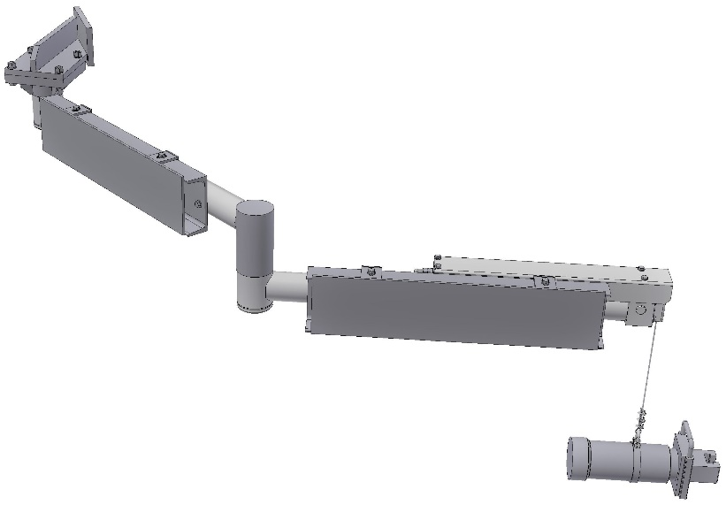

- Typical sketch for reference only -

CB.22. Tundish facility

CB.22.1A Tundish car semi gantry 1-strand

Technical Data

|  |  |
| --- | --- |
| Type of design | semi-gantry car |
| Carrying capacity | Approx. 70 t (trough + cover + content + Stopper rod) |
| Drive: |  |
| traveling | hydraulic |
| lifting | hydraulic |
| adjusting | hydraulic |
| Speeds: |  |
| Traveling / positioning | 20 m/min / 1.2 m/min |
| lifting | 30 mm/sec |
| adjusting | 5 mm/sec |
| Distances: |  |
| lifting | 600 mm |
| adjusting | ± 75 mm |
| Tundish weighing | weighing beams |
| Utilities and power supply | drag chain |

Functional Description

The tundish car serves for transporting the tundishes to the various locations on the casting floor. Once a tundish is placed in the saddles of the tundish car, it can be transported to and from the casting position and preheating position. The tundish car features lifting and lowering of the tundish to facilitate placement of the submerged entry nozzle (SEN) into the mold at the casting position. For positioning of the SEN in the mold, an adjusting device is provided on each car.

Manipulation of tundish trough is accomplished by means of bay crane.

Main Components

* Travelling frame
* Drive unit
* Lifting device incl. position transducer
* Adjusting device
* Weighing beams
* Covers and platforms
* Power track
* Machine attached piping
* Limit switch arrangement
* Ducting for mold dedusting

Main Characteristics

* Hydraulic travelling, lifting and adjusting
* Elevated track on operator side
* Statically determined three-point support for trough

Advantage of Design

* Good accessibility due to semi-gantry design
* Protection of mold caster operator against steel splashes by top cover
* Exchange of position transducer without disassembling of lifting device.

Reference Drawing CB.22.1A Tundish car semi gantry 1-strand

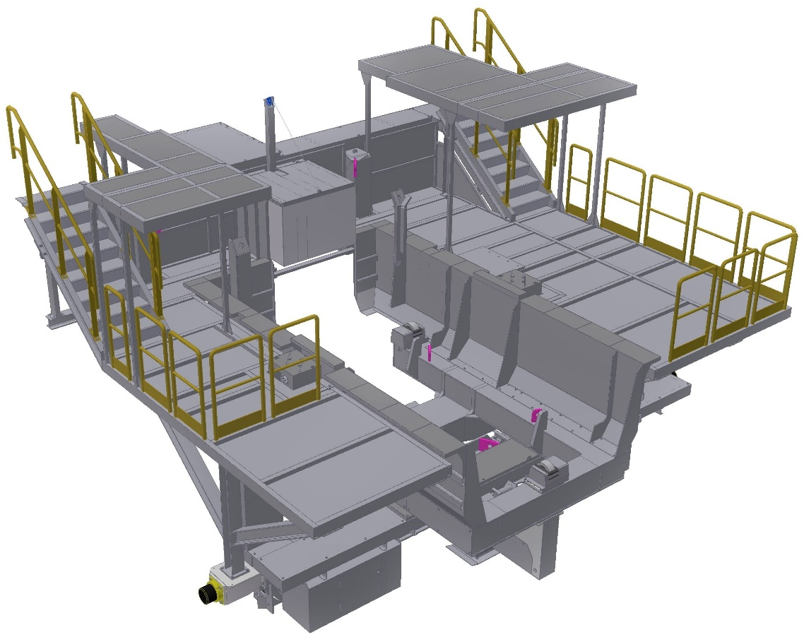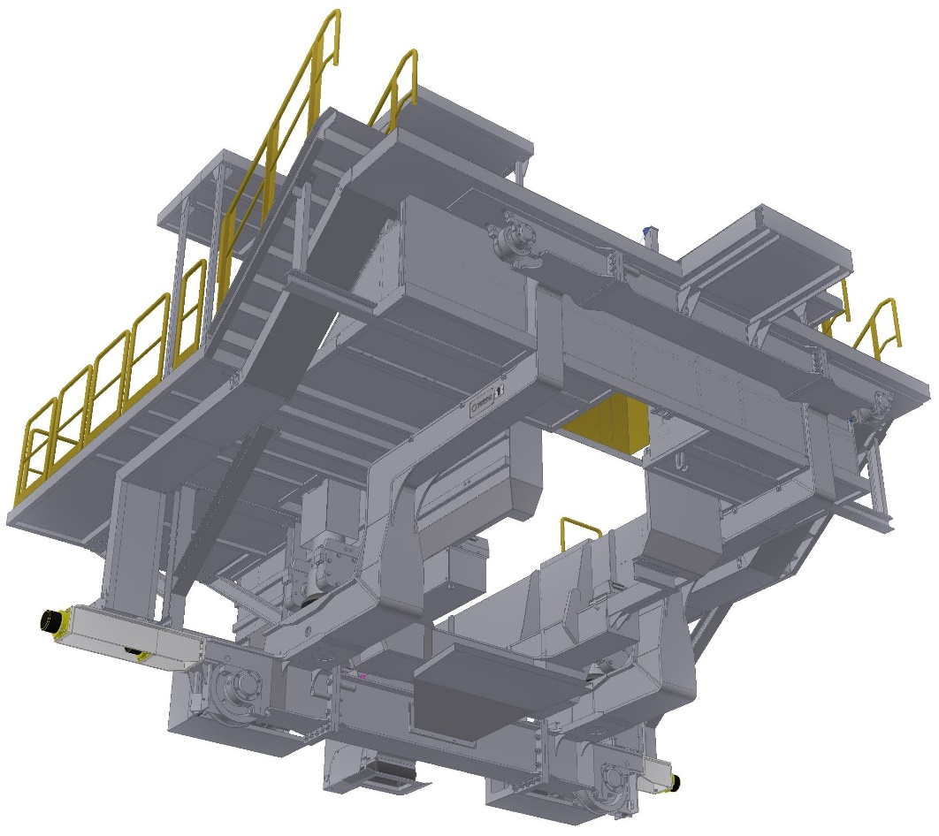

-Typical sketch for reference only-

CB.22.2 Tundish

Existing Tundishes will be reused. The following data are only for information.

Technical Data

|  |  |
| --- | --- |
| Type of design | trough distributor with overflow |
| Content / bath level: |  |
| nominal | 36 t / 1050 mm |
| maximum (overflow) | 38 t / 1150 mm |
|  |  |
| Type of flow control | stopper control with Electro-mechanical actuator |
| No. of nozzles | 1 |
| Distance from inlet to outlet | approx. 3 m (Existing) |

Functional Description

The tundish serves as a buffer between the ladle and the mold to make sequence casting possible. The tundish is designed to promote the flotation of non-metallic inclusions in the liquid bath by providing adequate retention time for the inclusions to float out of the steel. The steel flow from the tundish into the mold is controlled via a flow control system.

Main Components

* Trough with overflow spout, support feet and transport pin
* Supports for flow control equipment
* Refractory lining
* Cover plate for refractory lining

Main Characteristics

* Welded design
* Plane walls

Advantage of Design

* High liquid steel level and thus, good inclusion floatation
* Simple relining due to its geometric shape
* Possibility of installation of dam and weir to promote inclusion floatation

Reference Drawing CB.22.2 Tundish 1-strand

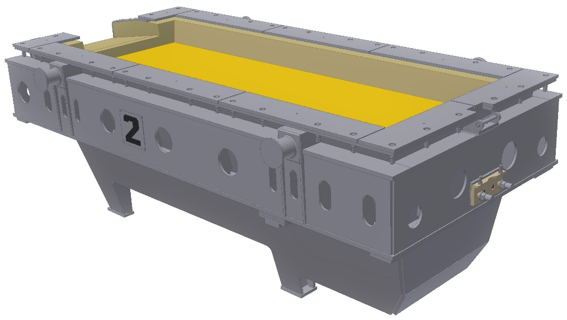

- Typical sketch for reference only -

CB.22.3 Tundish cover

Existing Tundishes will be reused. The following data are only for information.

Technical Data

|  |  |
| --- | --- |
| Type of design | simple welded steel frame with refractory lining |

Functional Description

The tundish cover prevents heat radiation during preheating and casting and serves as a splash protection when filling the tundish.

Main Components

* Steel frame
* Anchors for castable lining
* Refractory lining

Main Characteristics

* Openings for ladle shroud, tundish stopper, preheating burner, addition of tundish powder, temperature measurement, etc.

Advantage of Design

* Dimensionally stable light-weight structure

Reference Drawing CB.22.3 Tundish cover 1-strand

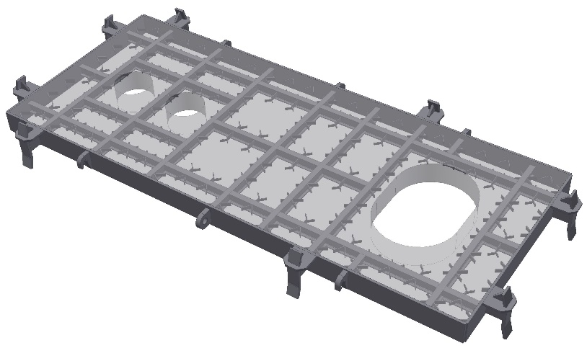

- Typical sketch for reference only –

CB.22.4 Tundish stopper control

Technical Data

|  |  |
| --- | --- |
| Stroke | 120 mm |
| Type of operation | automatic with electromechanical actuator when using the bath level control, manually via lever |

Functional Description

The stopper control serves for the control of the steel flow from tundish into the mold.

For details of the mold level measurement and the mold level control please refer to Chapter 4.2 Electric/Instrumentation/Automation (CB.9).

Main Components

* Stopper rod mechanism
* Hand lever
* Electromechanical actuator (not part of mechanical equipment > refer to CB.9)
* Stopper rod
* Connection for inert gas

Main Characteristics

* Stopper rod control with guide rollers
* Operation with electromechanical actuator or manual

Advantage of Design

* Smooth running stopper rod control
* Only little force to be applied by hand
* Simple fixation of stopper rod control mechanism and electromechanical actuator

Reference Drawing CB.22.4 Tundish stopper control

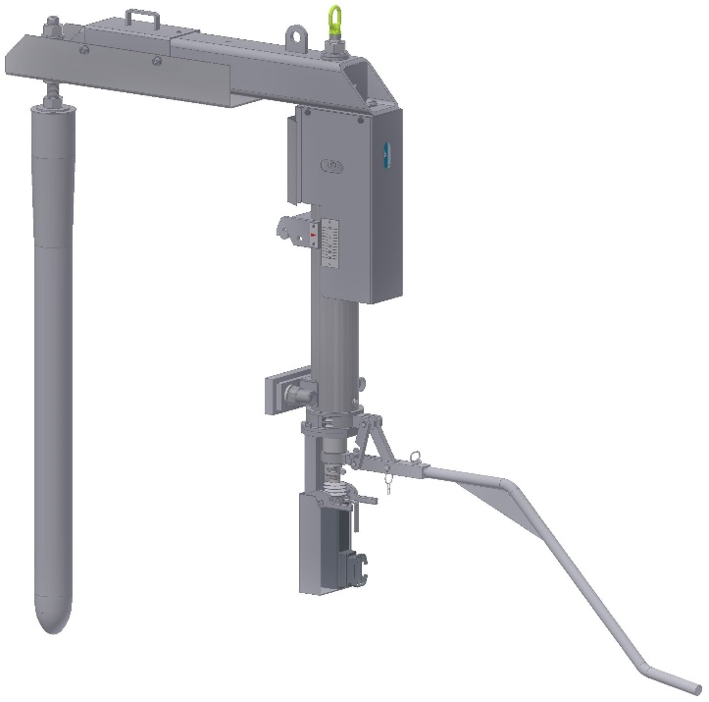

- Typical sketch for reference only -

CB.22.51B SEN changing device

Technical Data

|  |  |
| --- | --- |
| Type of design | hydraulic operated SEN quick change system with blank plate setting for clean shut off and argon supply |
| Location: | on tundish bottom |
| Manipulation: |  |
| nozzle moving | via hydraulic cylinder |
| setting of new nozzle: | manual with tong |
| removing of old nozzle: | manual with tong |
| Supply: |  |
| hydraulics: | from central system |
| nozzle sealing: | argon |
| Argon requirement |  |
| Flow | max. 100 litres/min |
| Pressure | 0.2 MPa |
| Nozzle changing time | approx. 1 sec (cylinder movement only) |
| Emergency closing | by blank plate |

Functional Description

The SEN quick change system allows longer sequences to be cast through each tundish, this reduces operating costs and improves caster yield. The SEN quick change system also provides an effective emergency shut-off facility.

The operation of the SEN quick change system depends on the slab width. For narrower slabs the casting speed is reduced and the tundish is lifted prior to SEN exchange, this may not be required for wider slabs. The safety blank plate is manually removed from the loading position and the new SEN inserted. The firing cylinder pushes the new SEN into casting position, this also pushes the old SEN out of the casting position. The old SEN is manually removed and the safety blank plate is inserted into the loading position. The tundish is then lowered and casting speed increased.

The tundish bottom to mold cover dimension will be determined to enable the changing of SEN’s without lifting the tundish for the majority of slab widths.

Main Components

* Quick change mechanism (fitted to the tundish bottom)
* Hydraulic valve stand (one per tundish car)
* Hydraulic cylinder (one per tundish car)
* Control system
* Maintenance tools
* Pipe work and hoses
* SEN handling tongs

Main Characteristics

* Hydraulic actuation
* Rapid operation for minimal disruption to casting
* Argon supply to minimise air ingress

Advantages of Design

* Quick exchange of SEN during casting
* Emergency shut-off facility
* Reduced refractory costs (higher sequences per tundishes)
* Improved product yield (fewer tundish skulls)

CB.23. Casting subsystem

CB.23.1 Preheating stations

CB.23.11 Tundish preheating station

Technical Data

|  |  |
| --- | --- |
| Heating capacity | max. 2020 kW |
| No. of burners | 3 |
| Fuel gas | LPG |
| Combustion air | by air fan |
| Tundish preheating temperature | max. 1100 °C |
| Preheating time | approx. 90 min to 120 min…*) |
|  | *)…final preheating procedure to be defined by the Buyer or refractory material supplier |

Technical Description:

|  |  |
| --- | --- |
| Type of design | package unit, controlled via local control panel |
| Ignition of burners | automatic incl. flame detection |
| Tilting drive | hydraulically |
| Burner control | automatic by programmable temperature controller |

Main Components

* Supporting structure
* Tilting frame
* Gas burners
* Heat protection covering
* Combustion air fan
* Gas / air control station
* Hydraulic tilting drive
* Electrical control panel

CB.23.12 SEN preheating device

Technical Data

|  |  |
| --- | --- |
| Type | gas burners |
| Type of design | moveable gas burners |
| Location | tundish preheating position |
| Fuel gas | LPG |
| Preheating temperature | approx. 900 °C |
| Preheating time | approx. 30 min |

Technical Description:

For preheating of the installed SEN (Submerged Entry Nozzle), gas burners are positions at SEN outlets

Main Components

* Burner support with gas/air-burner
* Gas regulation valve
* Flexible hoses

CB.23.2 Manipulators

CB.23.22 Ladle shroud manipulator manual

Technical Data

|  |  |
| --- | --- |
| Type of design | manual with hydraulic lifting |
| Location | one on each tundish car |
| Manipulation: |  |
| lifting and lowering | via hydraulic cylinder |
| turning | manual |
| forward / backward | manual |
| tilting of the tube | via hydraulic motor |
| Stroke | ladle stroke +100 mm |
| Horizontal movement | ± 300 mm |
| Slewing range: | 180° |
| Tilting range of the tube | 270° |
| Force acting against slide gate nozzle tip | varying from 0.5 to 2.0 kN |
| Supply: |  |
| Hydraulics | from central system |
| shroud tube sealing | argon |
|  |  |

Functional Description

The shroud tube is handled and manipulated by means of the ladle shroud manipulator mechanism. In addition to handling, the shroud tube manipulator secures the shroud to the underside of the ladle through a single hydraulic cylinder. This cylinder provides the necessary force to adequately seal the shroud to the ladle while following the ladle through the lifting and lowering movements.

Main Components

* Lifting column with integrated lifting cylinder
* Cantilever with shroud tube receiver and argon supply
* Hydraulic motor for tilting the tube
* Hydraulic control

Main Characteristics

* Cantilever movable in three axes
* Hydraulic lifting and lowering via manually operated valve
* Tilting of shroud with hydraulic motor via manually operated valve
* Argon supply

Advantages of Design

* Constant force of shroud tube acting against the outlet opening
* The shroud tube follows automatically the outlet opening in horizontal and vertical direction.

Reference Drawing CB.23.22 Ladle shroud manipulator (manual)

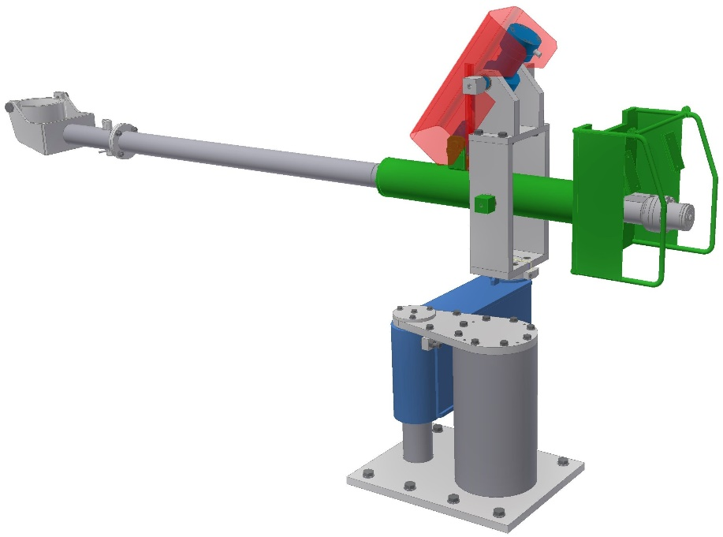

- Typical sketch for reference only -

CB.23.6 Pulpits

CB.23.61 Pulpit OS1

Technical Data

|  |  |
| --- | --- |
| Type of design | Welded design |
| Location | on casting platform |
| Movements: | Manual |

Functional Description

The mechanical equipment serves for fixing the control box of the mold operator.

Main Components

* Swivelling device
* Cantilever

Main Characteristics

* Operator stations are movable and can be shifted by the operator to the desired position.

CB.24. Support structure

CB.24.1 Machine supporting structure

Technical Data

|  |  |
| --- | --- |
| Type of design |  |
| supporting structure of caster | structural steel construction in the machine area (only between concrete walls) and for tundish car railways. concrete construction for all other casting platforms and supporting structure |
| ladle operator platform | steel structure |
| ladle slide gate platform | steel structure |
| support for emergency ladle | concrete |
| support for tundish car rails | concrete and LOP (for semi-gantry car) |
| Size of casting platform: | please refer to layout drawing |
| concrete wall distance | please refer to layout drawing |
| total area | please refer to layout drawing |
| Casting platform: |  |
| max. surface load | 2.0 t/m² (designed for storage of casting material e.g. powders) |
| defined storage area | designed for intermediate storage of 2 molds or 2 benders or 2 segments in a defined area (refer to layout) |
| Intermediate platform: |  |
| max. surface load | 1.0 t/m² |
| Other platforms (maintenance) |  |
| max. surface load | 0.5 t/m2 |
| Stairs and cross-covers |  |
| surface load | 0.35 t/m² |
| Elevation above ground level: |  |
| casting platform | please refer to layout drawing |
| ladle operator platform | please refer to layout drawing |
| intermediate platform | please refer to layout drawing |
| Platform surfacing: |  |
| in the liquid steel working area | refractory concrete |
| remaining area | concrete |
| intermediate platform | checkered steel plate or concrete |
| other platforms, stairs and cross covers | checkered steel plate |

Functional Description

The machine supporting structure mainly consists of the casting floor, intermediate floor, stairs and cross walks, and required platforms which are required for the functionality of the machine. The main supporting columns of the casting floor and intermediate floor are mounted directly to the concrete foundation. The casting platform serves as a working area for the operating personnel during the casting process. The utility supply rooms (hydraulic, water, and electric’s) can be located below the main casting platform on the intermediate level nearer to the casting machine components.

For manufacturing of steel construction, local standards and profiles can be used, according to the

manufacturing locations.

Main Components

* Casting platform incl. intermediate platform with platform supporting structure
* Track for tundish car
* Ladle operator platform with track for cable chain
* Ladle slide gate platform
* Stairs, railings, cross-overs
* Guides for segment exchange
* Liftable coverings for segment exchange
* Anchoring material

Main Characteristics

* Absorption of loads via the combined concrete / structural steel construction by the foundation
* Detachable coverings for the access to the components located under the casting platform
* Accessibility for maintenance and operation
* Emergency exits according to the safety regulations
* Heat and splash protection facilities according to safety regulations

Advantages of Design

* Low-vibration design minimizing thermal expansion by combined concrete / structural steel construction

CB.24.2 Cooling chamber

Technical Data

|  |  |
| --- | --- |
| Type | tunnel type |
| Material: |  |
| inside lining | stainless steel (e.g. 1.4301 or similar) |
| supporting structure | carbon steel |

Functional Description

The cooling chamber is provided to collect the steam developed during the casting process. The steam is then removed by the steam exhaust system. The spray chamber also protects the environment against heat radiation from the slab.

Catwalks are located along both sides of each strand guide enclosed by walls and covers.

The covers in the centerline of each strand are integrated in the segments.

The cooling chamber is provided with doors. They are located on both sides at floor level and at catwalk level.

The walls, covers and catwalks are supported by a steel structure.

Adequate openings are provided for the steam exhaust system.

Main Components

* Cooling chamber steel structure
* Cladding
* Stairs and landings
* Catwalks, safety fence(s) and electrically monitored lockable safety door(s)
* Break out protection (ply wood covered steel plates)

Main Characteristics

* Enclosure of strand guide / containment
* Collection of steam for the exhaust system
* Provision of space for inline maintenance and inspection work
* Provision of lateral access to the segments
* Break out protection to minimize the damage after a break-out

Advantages of Design

* Accessibility for in-line maintenance and inspection work
* Low corrosion steel for lining

CB.24.3 Steam exhaust system

Technical Data

|  |  |
| --- | --- |
| No. of fans | 2 per strand |
| Capacity per fan | 90000 m³/h (for 3 horizontal segments)  120000 m³/h (for “average caster”)  180000 m³/h (for long strandguide, e.g. Ha Tinh) |
| Suction medium | steam / air mixture |
| Static pressure | approx.. 1600 Pa |
| Temperature of medium | max. 80°C |
| Material: |  |
| fan housing | stainless steel AISI 304L |
| impeller | stainless steel AISI 316L |
| Ducts | Low corrosion steel plate galvanised |

Functional Description

The steam generated by spray cooling is collected in the cooling chamber and expelled to the atmosphere via ducts and stack.

Main Components

* Fans, single inlet, with direct drive incl. motor (motors are part of electric equipment)
* Suction ducts with control damper
* Pressure ducts and stack

Main Characteristics

* Fans sucking in on one side with direct drive
* Stainless Galvanised steel design of ducts and stacks
* Fans supported by vibration absorbers
* Control dampers in the ducts
* Fans with vibration and temperature monitoring for the bearings
* Electric drive (see CB.9 Electric & Automation)
* Automatic lubrication unit for the bearings

CB.24.4 Emergency casting system

Technical Data

|  |  |
| --- | --- |
| Type of design |  |
| Overflow box | welded trough |
| Protection wall | panel segments |
| Slag box | welded trough  one full tundish content |

Functional Description

The emergency casting system serves for protecting of casting platform in case of tundish overflow and during ladle turning to emergency ladle.

The slag boxes are able to receive slag and/or steel when the tundish is out of casting position and the stopper rod cannot be closed completely.

Main Characteristics

* Welded design
* Plane walls

CB.25. Smart Machine head

Reference Drawing CB.25 Machine head

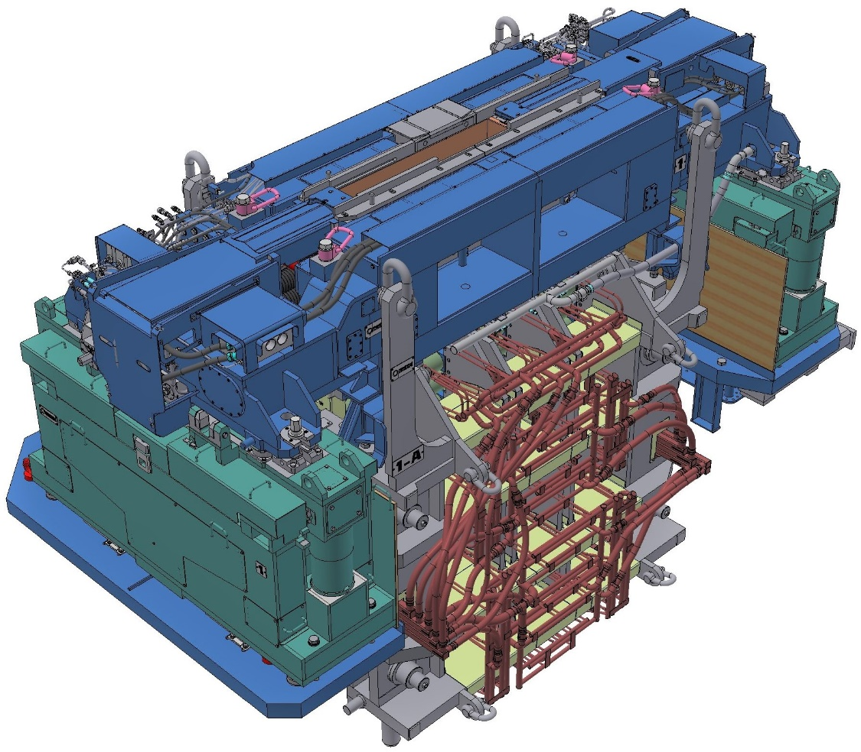

- Typical sketch for reference only -

CB.25.1 Smart Mold

Technical Data

|  |  |
| --- | --- |
| Type of design | straight plate mold with width adjustment |
| Width adjustment range (cold size) | 850 - 1680 mm |
| Thickness adjustment range (cold size) | 160 - 220 mm (max. 280 mm) |
| Equipped for slab thickness | 220 mm |
| Material of copper plates | CuAg (CuCrZr on low wear limits) |
| Coating of copper plates | Ni-coating, 0.5/1.5 mm |
| Length of copper plates | 900 mm |
| Thickness of copper plates: |  |
| wide and narrow side | 40 mm |
| Minimum thickness after several remachinings | 25 mm |
| Cooling water supply in the copper plates: |  |
| wide side | slots |
| narrow side | slots |
| Cooling water connection | automatic when depositing the mold |
| Foot rollers per wide side: |  |
| Type of roller | intermediately supported roller with fixed axle, wear-resistant surface and innovative grooved design |
| quantity | 1 |
| barrel length | approx. 1700 mm |
| type of bearings | roller bearing |
| No. of intermediate supports | 2 (tripartite roller) (1 up to 1500 mm, 2 for 1501 to 2600, 3 for >2601 mm) |
| roller diameter | 100 mm |
| Foot rollers per narrow side: |  |
| quantity | 0 for maximum casting thickness 160mm  1 for maximum casting thickness 180mm  4 for maximum casting thickness 220mm  3 for maximum casting thickness 300mm  4 for maximum casting thickness 350mm  5 for casting thickness >350mm |
| type of bearings | roller bearing |
| roller diameter | 100 mm |
| Roller jacket material | Roller with corrosion resistant surface |
| Roller surface | build up welding for reduced wear |
| Fixing of wide side foot rollers | with expansion bolts at mold frame |
| Width adjustment: |  |
| Type of movement | hydraulically with automatic control |
| No. of cylinders | 4 |
| Location of cylinders | on mold |
| Type of drive | manual |
| Type of drive | electromechanical with automatic control |
| No. of drives | 4 |
| Location of drive unit | on mold table |
| Expansion of wide side | hydraulic |
| Type of clamping | with disk springs |
| Roller cooling | external cooling by spray cooling |
| Lubrication of foot rollers | central lubrication system |
| Material for machine attached piping: |  |
| Secondary cooling systems | stainless steel |
| Hydraulics | stainless steel |
| Lubrication | stainless steel / copper / brass |
| Instrument air | stainless steel / copper |

Functional Description

The Smart Mold provides the required strand geometry and primary heat removal during the initial development of the strand shell. Primary cooling water passed along the inside of the copper plates provide the efficient convective heat transfer.

The DynaWidth adjustment for the various section sizes is made via moving the narrow face assemblies of the Smart Mold. The narrow face assemblies can be shifted perpendicular to the casting direction by means of an adjusting mechanism.

The casting thickness is changed by exchanging the narrow face assemblies.

Main Components

* Mold frame with water supply, centering and fixing device
* Mold cassettes consisting of copper plates fixed with bolts onto the back-up plates building a unit
* Combined clamping and expanding device
* Width adjustment device with position transducers
* Foot rollers for wide and narrow side
* Component piping for hydraulics, cooling and lubrication
* Thermocouples, plugs and component cabling for breakout prediction

Main Characteristics

* Automatic centering of mold when it is placed on the mold table
* Automatic cooling water connections for primary and secondary cooling when the mold is placed on the oscillator table
* Independent supply of cooling water quantities for narrow and wide side
* Combined clamping and expansion of mold wide side
* Variable gap adjustment for width adjustment or cleaning purposes
* Hydraulic linear drives for width adjustment
* The mold is of a modular design to facilitate easy and rapid exchange at the casting machine.
* Uniform temperature distribution by straight copper plates
* Narrow side foot rollers overload protected and fixedly mounted wide side foot rollers
* Weight optimized design

Advantages of Design

* High operational safety due to uniform growth of strand shell
* High precision and long life of width adjustment system
* High adjusting speed at maximum casting speed possible, reducing the length of the transition piece for increased yield
* Simple remachining and adjustment of straight copper plates
* Minimization of non-metallic inclusions in the strand by unhindered floating of non-metallic particles
* Simple inline adjustment of transition between foot roller and bending zone
* Easy disconnection of foot rollers from mold top after a breakout
* Automatic cooling water connections for primary and secondary cooling when the mold is placed on the oscillator table.
* No mold storage stand required
* Quick change cassette system reducing the turnaround time and number of spares

Reference Drawing CB.25.1 Smart Mold

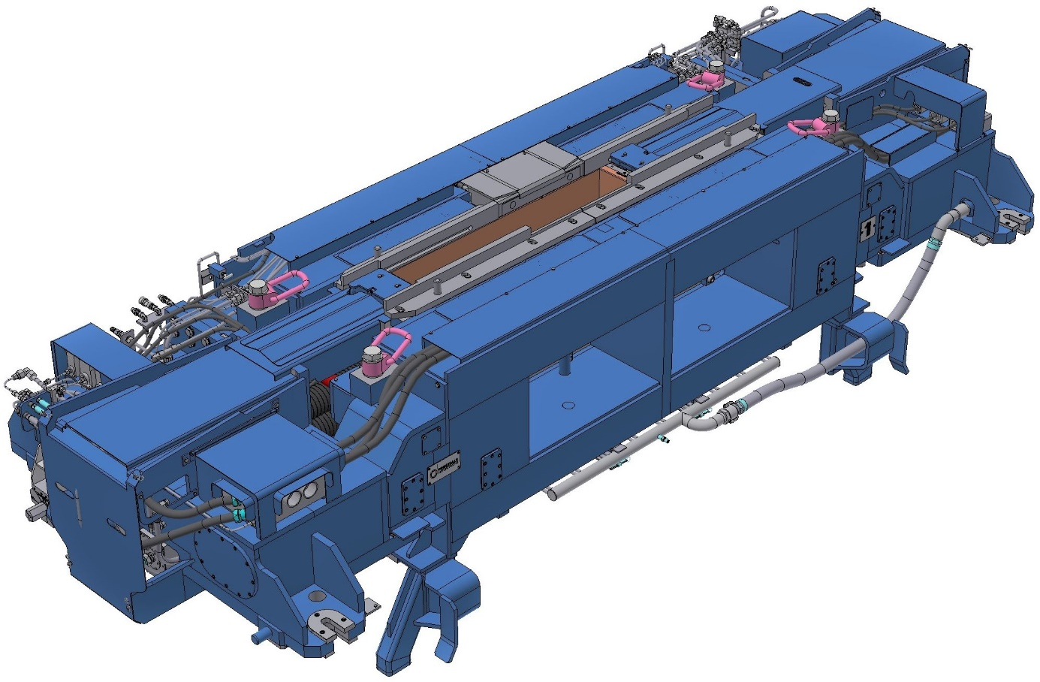

- Typical sketch for reference only –

CB.25.5 Mold subsystem

Please refer to annex 4.2

CB.25.6 Mold cover

|  |  |
| --- | --- |
| Type of design | welded design |

Main Components

* Main cover
* Moveable inner cover

Reference Drawing.25.6.Mold cover

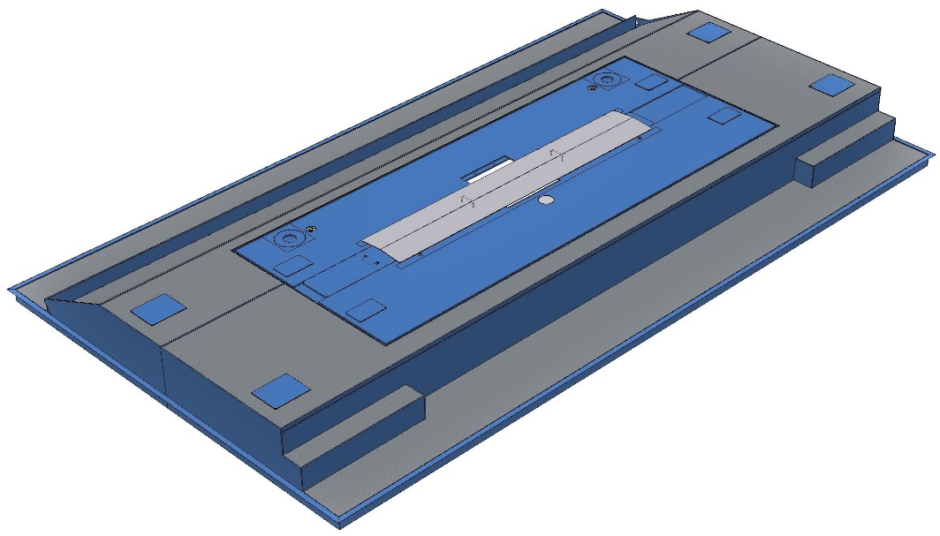

- Typical sketch for reference only –

CB.25.7 Mold fume exhaust system

Technical Data

|  |  |
| --- | --- |
| No. of fans | 1 per strand |
| Fan capacity | approx. 8000 m³/h |
| Static pressure at fan | approx. 1500 Pa |
| Suction medium | casting powder contaminated dust / flue gas / air mixture |
| Temperature range of medium | 10 to 100°C |
| Material: |  |
| Fan | stainless steel AISI 316L |
| Ducts | 1.5mm stainless steel plate (1.4301) |

Functional Description

The mold exhaust system removes fume and dust occurring in the area of the mold on the casting platform when adding casting powder.

The accumulated dust is sucked in through a duct (part of tundish car) in the area of the mold wide side and discharged via a piping system into the scale flume inside the cooling chamber.

Main Components

* Fan with motor
* Vibration absorber
* Stainless piping with flexible connections

Main Characteristics

* Suction opening in the area of the mold wide side is part of the tundish car
* Radial-fan

Advantages of Design

* Dust-reduced environment in the mold area

CB.25.8 DynaFlex Oscillator

Technical Data

|  |  |
| --- | --- |
| Type of design | hydraulically driven |
| Number of units installed | 2 per strand (identical design) |
| Lifting stroke | 0 - 12 mm (± 6 mm) |
| Oscillation frequency range: |  |
| Design range: | (Design window see below) |
| minimum | 40 strokes / min |
| maximum | 400 strokes / min |
| Max. acceleration | 4.9 m/s2 |
| Oscillation curve | sinusoidal or non-sinusoidal with non-sinusoidal factor of 0.5 to max. 0.7 |
| Type of design of mold guide | flexible pretensioned leaf springs to guide the mold |
| Cooling water connections | self joining when oscillator is deposited |

Design window

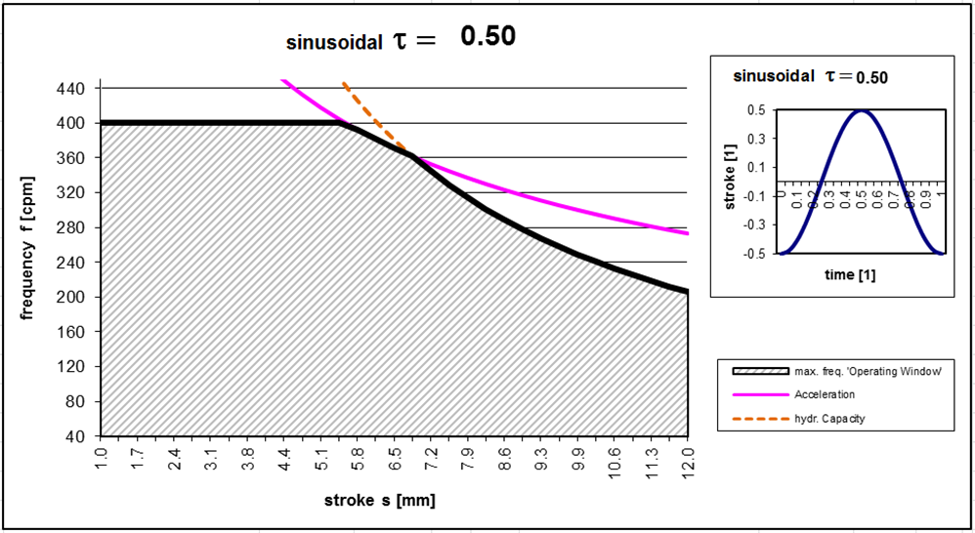

Functional Description

The DynaFlex Oscillator provides the necessary movement of the mold to prevent sticking of the stand shell to the copper plates. The hydraulic drive is such that a sinusoidal or non-sinusoidal oscillation pattern can be selected along with on-line stroke and frequency adjustment.

Main Components of each oscillator unit

* Oscillator base frame
* Water cooled linear drive for oscillating unit with control valve, synchronization control and control unit
* Mold table with mold support, centering & fixation unit
* Wear free & prestressed mold guidance system (leaf spring type)

Main Characteristics

* Support and guide of mold by means of oscillator base frame, mold tables and mold guides
* Self joining water connections for primary and secondary cooling when the mold is placed on the oscillator table
* On-line adjustment of oscillation parameters such as:
* Stroke
* Frequency
* Wave pattern (sinus / non-sinus)
* Use of proportional valve for oscillation movement
* Vertical movement and horizontal guidance by two DynaFlex units of the same design
* Weight compensation with helical springs to reduce cylinder forces
* Cylinder directly connected to the mold table, therefore considerable reduced elastic deformation in the system

Advantages of Design

* Improved product quality due to high guiding accuracy
* Long life due to wear free leave spring precision guiding system
* Reduced number of operational exchange parts required due to identical design of the oscillation units
* Connected to main hydraulic system, no special hydraulic system required
* Minimum space needed thanks to cascaded leaf springs
* Short disassembly time for the oscillator
* Good accessibility for changing and maintenance work

Reference Drawing CB.25.8 DynaFlex Oscillator

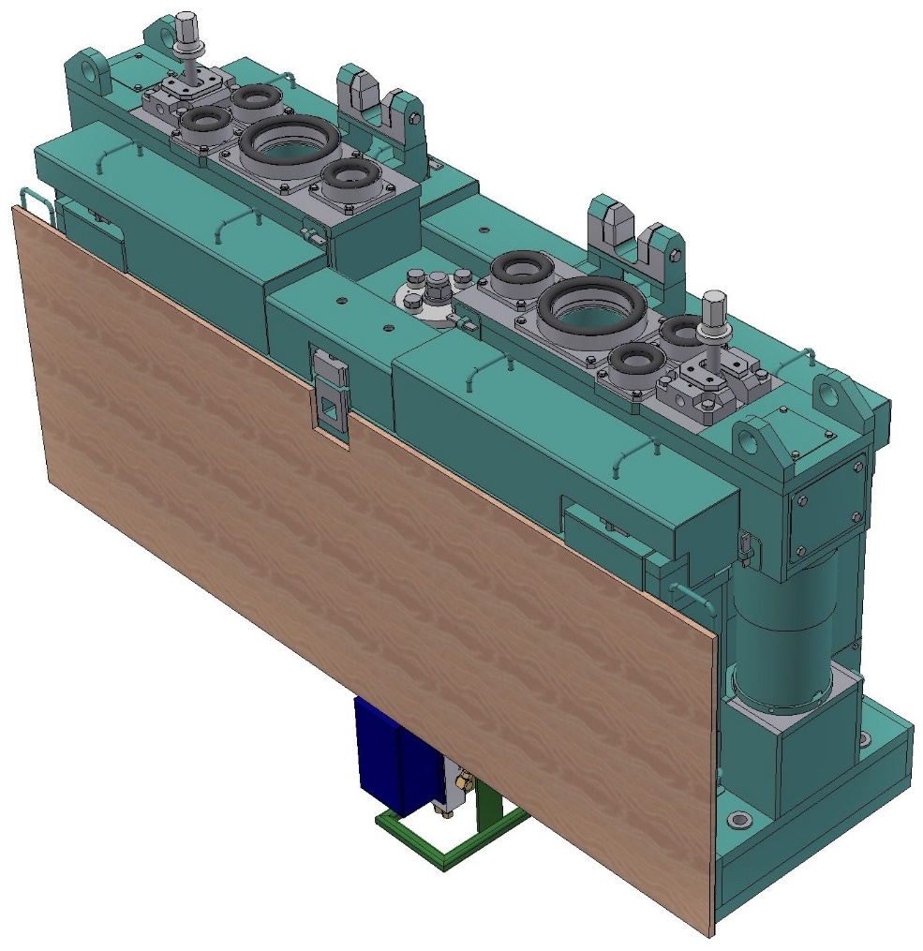

- Typical sketch for reference only –

CB.25.9 Oscillator support structure with bender support

Technical Data

The oscillator units are supported by a foundation frame with bender support. The foundation frame with bender support is bolted to the embedded oscillation anchorage. Water for mold is connected to the foundation frame with bender supports via rubber seals.

The primary mold water and metallurgical cooling in the foot roll area are made through automatic connections.

Main Components

* Foundation support with centering device
* Self joining connection of water for mold

Reference Drawing CB.25.9 Oscillator support structure (with bender support)

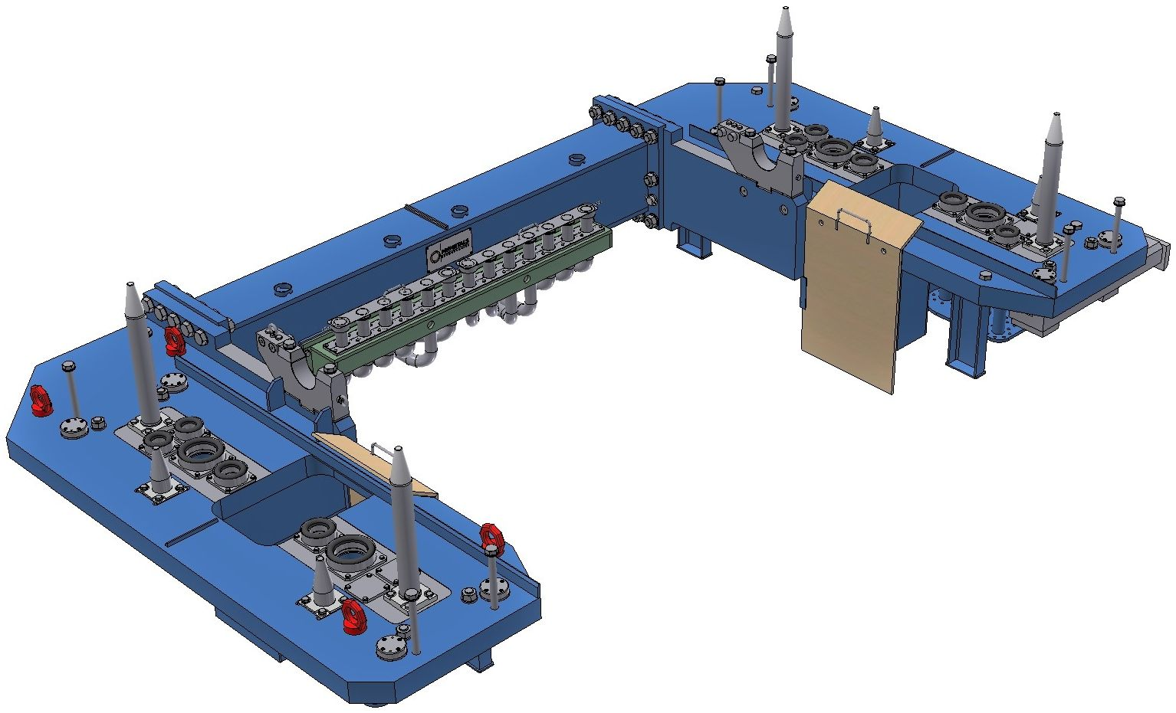

- Typical sketch for reference only –

CB.26 Strand guide

CB.26.1A Bender

Technical Data

|  |  |
| --- | --- |
| Bending method | according to PT’s continuous bending curve |
| No. of rollers per unit |  |
| inner bow | 16 |
| outer bow | 16 |
| Roller diameter (mm) | 150 / 175 |
| No. of intermediate supports | 2 |
| No. of bearings per roller | 6 |
| Type of bearings | roller bearing |
| Type of rollers | split roller jacket on a continuous fixed axle with intermediate supports |
| Roller jacket material | S355J2 or equivalent (EMS involved rollers: X6NiCrTi26-15 = DIN Werkst.Nr. 1.2779) |
| Roller surface | build up welding for reduced wear |
| Gap adjustment | by means of shims |
| Roller jacket cooling | outside by spray cooling |
| Lubrication | central lubrication system |
| Material for machine attached piping  secondary cooling  lubrication | stainless steel  stainless steel / copper / brass |

Functional Description

The bending unit is provided to guide, contain, and bend the hot strand from its vertical position into the constant radius according to PT’s continuous bending curve.

Main Components

* Inner and outer frame with tie rods
* Strand guide rollers
* Component piping with nozzles
* Protection coverings

Main Characteristics

* Self-joining positioning of bending zone in the oscillating foundation frame and on the segment support structure.
* Connection of inner frame with outer frame by means of tie rod and screw nut
* Thickness adjustment by means of shims
* Inner and outer frame with roller girders arranged in casting direction
* Intermediate supported rollers

Advantages of Design

* Low stress of strand shell by continuous bending
* Low bulging by optimized roller diameter and roller pitch due to intermediate supported rollers
* Easy and quick change of components
* Self-joining connection to water system when inserting the bending zone
* Rigid design
* All roller bearings of standard design
* Long life of rollers due to build up welding
* Surfaces between inner- and outer frame,which will be released during frequent operational adjustments e.g. thickness change, are made out of stainless material or with stainless weld on.

Reference Drawing CB.26.1A Bender

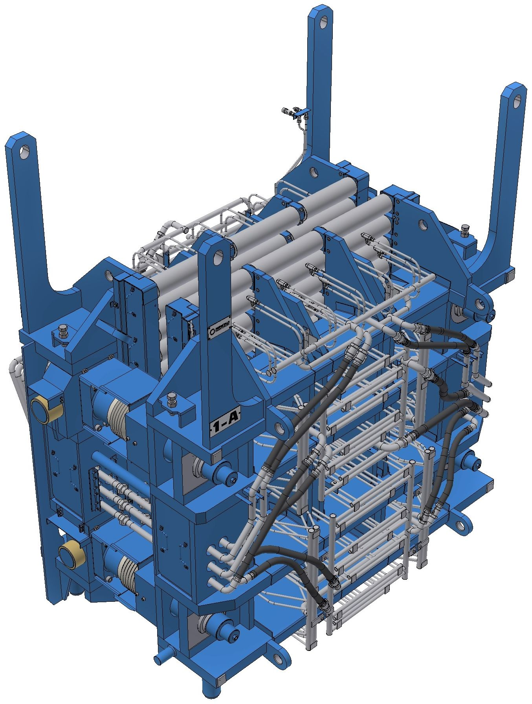

- Typical sketch for reference only –

CB.26.2-4 Smart Segments

The strand guide system below the bender consists of the following segment types.

CB.26.2A / CB.26.2B Smart Bow segment A and B

Type A: installed in segment position 1 – 2 (adapt according actual roller geometry!)

Type B: installed in segment position 3 – 5 (adapt according actual roller geometry!)

The Bow Segments Type A and B are of different design (number of rolls, roller diameters) and are therefore not interchangeable.

*Use this sentence if only Type A is executed:*

Type A: installed in all bow positions.

CB.26.3A / CB.26.3B Smart Straightener segment A and B

Type A: installed in segment position 6 (adapt according actual roller geometry!)

Type B: installed in segment position 7 (adapt according actual roller geometry!)

The Straightener Segments Type A and B are of same design but executed with different roller positions according to roller geometry. The different roller positions are achieved by use of individual adapters and shimming. Therefore, Type A and B are interchangeable, however this requires re-shimming of the rollers.

CB.26.4A Smart Horizontal segment

Type A: installed in all horizontal positions.

The following technical specification is valid for all segment types.

Technical Data

Standard Gap adjustment: **DynaGap**

For “Clamped on Shims” please consider pink marking and delete the green lines.

| Roller Data  (cross-check with actual RollGeo!) | CB.26.2A  Bow Segments  Type A | CB.26.2B  Bow Segments  Type B | CB.26.3A+B Straightener Segments | CB.26.4A  Horizontal Segments |
| --- | --- | --- | --- | --- |
| No. of Rollers per unit | 16 | 14 | 16 | 16 |
| Roller diameter idle (mm) | 200 | 230 | 250 | 250 |
| Roller diameter driven (mm) | 250 | 250 | 250 | 250 |

|  |  |
| --- | --- |
| Type of bearings | Roller bearing |
| No. of bearings per roller | 4 |
| Type of rollers | Intermediate supported roller with high load carrying capacity and low roller body spacing |
| No. of intermediate supports | 2 |
| Roller jacket material | 42CrMo4 or equivalent (25CrMo4 or 21CrMoV5.11 for peripheral cooled rollers > verify selection with design group / Mr. Starrermair) |
| Roller surface | build up welding for reduced wear |
| Roller barrel length (mm) | appr. 1650 |
| Drive arrangement | refer to roller-geometry |
| Type of drive | electric motor, gear and universal joint shaft |
| Adjustable roller | inner driven roller |
| Girder arrangement | cross girder type |
| Gap adjustment | hydraulic adjusting device with remote gap control (DynaGap) hydraulically clamped on shims |
| Lubrication | central lubrication system |
| No. of hydraulic devices |  |
| segment clamping | 4 per segment |
| drive roll adjustment | 1 per segment (2 for twin cast or width >2500mm) |
| Type of cooling |  |
| roller jacket | outside cooling by spray cooling  internal peripherical cooling by closed machine cooling by means of subsurface spiral-type cooling channels (ECO Star Spiral) |
| roller axle | closed machine cooling |
| bearing housing | closed machine cooling |
| Material for machine attached piping |  |
| Secondary cooling | stainless steel |
| Machine cooling | stainless steel |
| Hydraulics | carbon steel |
| Lubrication | stainless steel / copper / brass |
| Nozzle arrangement for secondary cooling |  |
| Bow and Straightener Segments: | 3D-Sprays / Spray width adjustment for flexible spray pattern and to avoid overcooling of corners |
| Horizontal Segments | fixed |

Functional Description

The Smart Segments guide and support the hot strand and dummy bar.

The roller gap in the segments is automatically adjusted based on the position sensors in the hydraulic thickness adjusting devices (“clamping devices”).

Main Components

* Inner and outer frame with roller cross girder, tie rod and guiding column
* Strand guide rollers
* Thickness adjustment - outside cooling chamber
* Adjusting mechanism for upper drive roller - outside cooling chamber
* Machine attached piping
* Spray nozzles
* Cooling chamber plates
* Hydraulic clamping device - outside cooling chamber
* For DynaGap Segments only: (Use this header only if both shimmed and DynaGap Segments are installed!)
* Hydraulic adjusting devices with integrated position transducer - outside cooling chamber
* Machine attached cabling incl. special plug

Main Characteristics

* The Smart Segment is designed for the use of standard directional hydraulic valves instead of expensive, sensitive and maintenance-intensive servo-valves. (PT patent)
* Self-joining positioning of segments on the support structure
* Connection of cooling water and air piping to the bow segments are self-joining; lubrication and hydraulic piping are connected by quick connection couplings.
* Lifting, lowering of upper driven roller by means of hydraulic cylinder
* Inner and outer frame with roller girders arranged transversally to casting direction
* Surfaces between inner- and outer frame,which will be released during frequent operational adjustments e.g. thickness change, are made of stainless material or with stainless weld on.
* Intermediate supported rollers with internal cooling via rotary joint and bearing cooling
* Reduced segment deflection due to rigid design
* Easy and quick exchange of rollers outside of the machine with automatic water and grease connections
* All segments are overload protected by pressure relief valves installed at segment clamping devices.
* On segment no hoses inside cooling chamber
* Segments are interchangeable (for straightener re-shimming of rollers is necessary)
* Straightening according to PT’s continuous straightening curve (PT patent)
* Thickness adjustment for the casting thickness specified by shims
* For DynaGap Segments only: (Use this header only if both shimmed and DynaGap Segments are installed!)
* Capability to adjust any desired gap profile even during casting with the DynaGap System
* For Soft Reduction DynaGap calculates the roll gap profile based on actual casting conditions 🡪 Dynamic Soft Reduction
* Adjustment of spray pattern for secondary cooling in bow and straightener segments with 3D-Sprays

Advantages of Design

* Easy and quick adjustment of thickness by remote gap control (DynaGap)
* Low bulging by optimized roller diameter and roller pitch due to intermediate supported rollers
* Long life of rollers due to build up welding
* Low stress of strand shell by continuous straightening
* Check of alignment in the machine possible due to very good lateral accessibility
* For DynaGap Segments only: (Use this header only if both shimmed and DynaGap Segments are installed!)
* Soft clamping feature for machine protection (extended lifetime of equipment)
* Improved product quality with DynaGap Softreduction and minimized segment deflection
* Capability to cast slabs with any desired dynamically adjustable gap profile

Reference Drawing CB.26.2A Smart Bow segment

Remark:

This typical drawing shows secondary cooling with 3D-Spray / Spray Width Adjustment. However, the segments are only equipped with 3D Sprays if this is explicitly included in the specification and scope list.

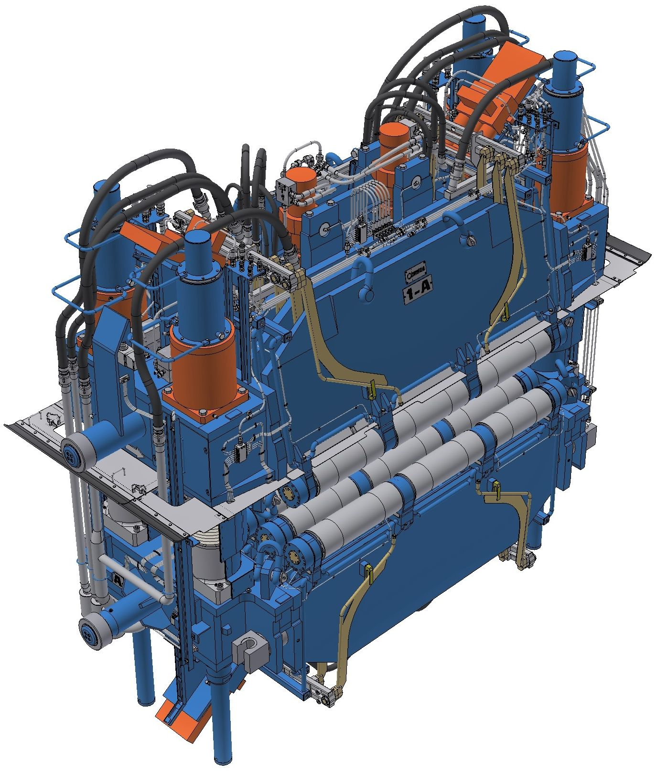

- Typical sketch for reference only –

Reference Drawing CB.26.3A Smart Straightener segment

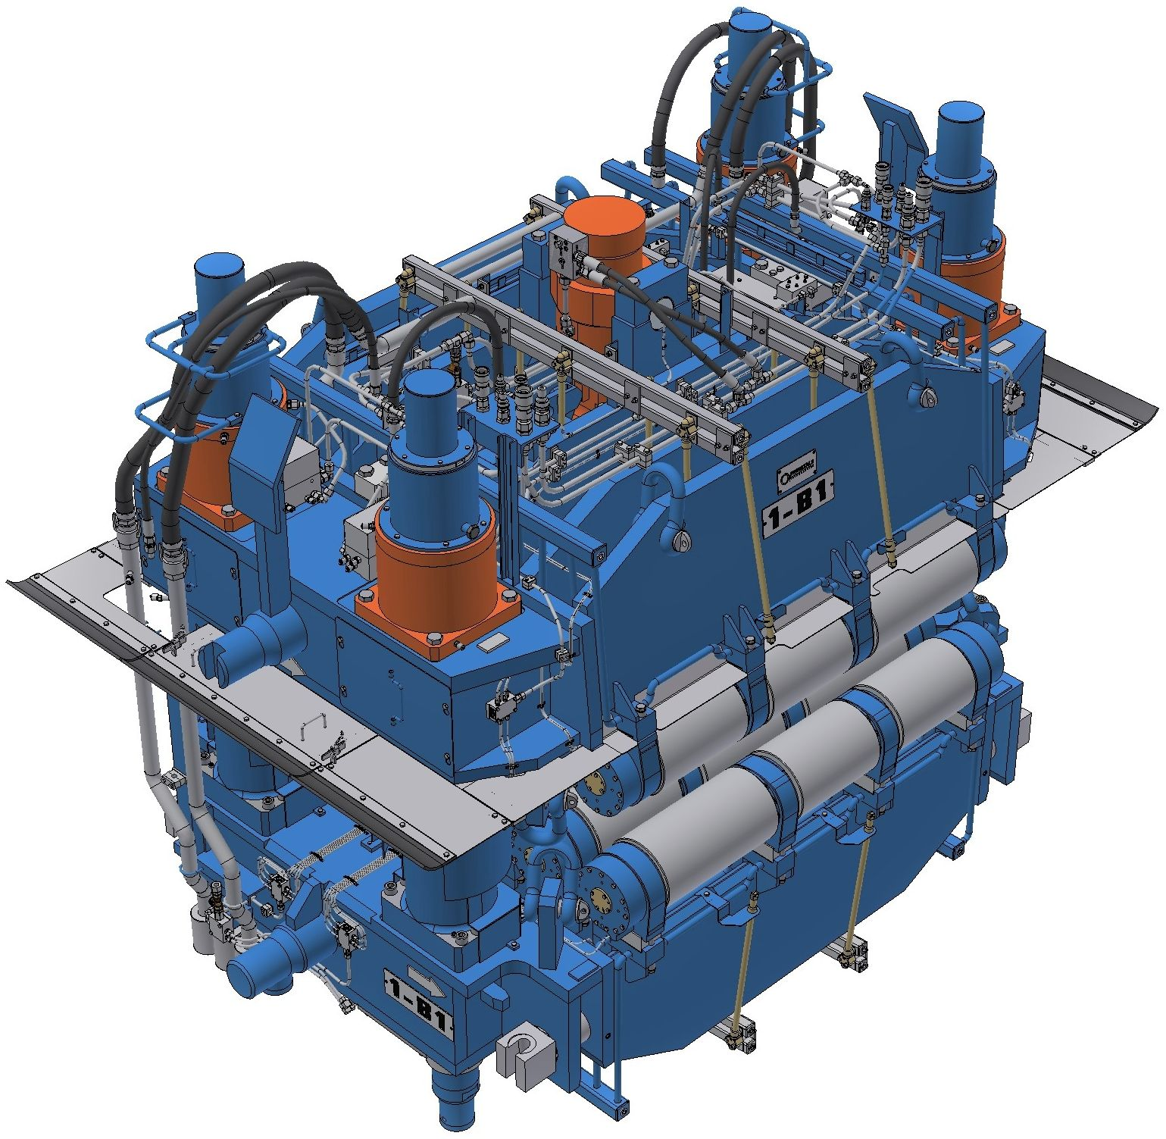

- Typical sketch for reference only –

Reference Drawing CB.26.4A Smart Horizontal segment

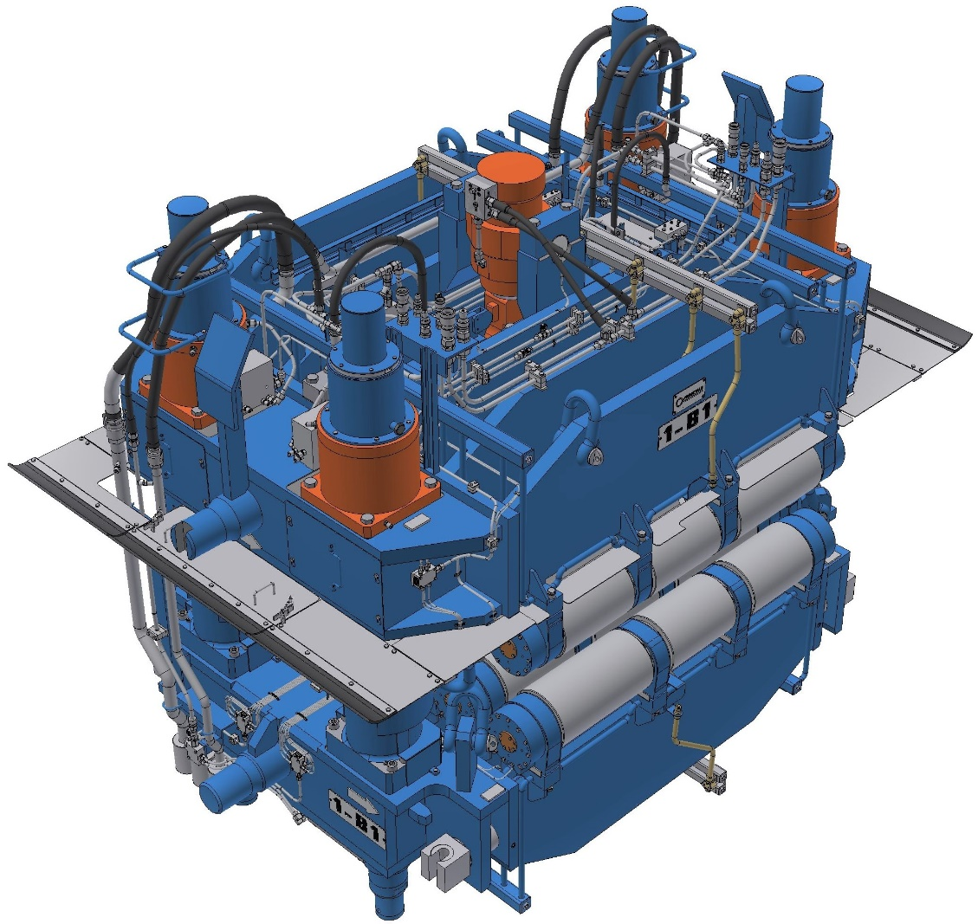

- Typical sketch for reference only –

CB.26.5 Strand guide subsystem (OPTION)

CB.26.53 Electromagnetic strand stirrer (S-EMS) (OPTION)

CB.26.53A Flow Master Box

Technical Data

|  |  |
| --- | --- |
| Type of design | Box-type electromagnetic stirrer (EMS) for Stirring of liquid steel by strong dynamic magnetic fields |
| Type of cooling | Dry type coil with internal water cooling |
| Rated current | 1700 A |
| Rated voltage | 680 V |
| Apparent power | 2000 kVA |
| Active power | 600 kW |
| Operating frequency | 2-3 Hz |
| Dimensions (approx.) WxLxH | 1600X1400X800 mm |
| Weight (approx.) | 5000 kg |
| Position of Flow Master Box | Bender outer bow (to be defined by ME!)  Bow Segment 1 inner bow (to be defined by ME!)  Bow Segment 2 inner bow (to be defined by ME!) |
| Manipulation of Flow Master Box in bender area | By manipulator in bender area, refer to item CB.23.24 |
| Manipulation of Flow Master Box in segment | The Flow Master Box is directly attached to the inner bow of the segment |

Functional Description

The Flow Master Box is a box-type electromagnetic strand stirrer (S-EMS) that is situated close to the strand.

The S-EMS generates a strong travelling electromagnetic field inside the strand, which induces a fluid flow inside the liquid pool. This flow leads to temperature homogenization of the liquid pool on the one hand and generates shear stress in the solidification front, on the other hand.

Both effects disturb columnar crystal growth and lead to a smaller grain size in the microstructure of the final product. This stirring effect can be quantified by the so called equiaxed ratio, which means the percentage of crystals below a certain length/width ratio in the microstructure.

The Flow Master Box contains electrical coils and an iron core. The coils are made of hollow copper, with internal water cooling. A phase shift in the AC currents in the coils generates a linear travelling magnetic field and the iron core brings this field to the strand.

Main Components

* Box-type coil
* Manipulator (optional): Please refer to item CB.23.24 (Das ist aber nur für Bender?)
* Cooling water station: Please refer to fluid specification item CB.XX
* Electric power supply: Please refer to E&A specification item CB.XX

Main Characteristics

* Travelling magnetic field inside the strand
* Fluid flow inside the liquid pool of the strand
* Homogenization of temperature distribution in the liquid pool
* Shear stress in solidification front
* Increase equiaxed ratio in final product

Advantages of Design

* Strong travelling magnetic field
* Retract coils to safe position when not in operation (only if manipulator is installed)
* Robust and reliable design

Reference drawing CB.25.53 Flow MasterBox (shown for installation in bender with manipulator!)

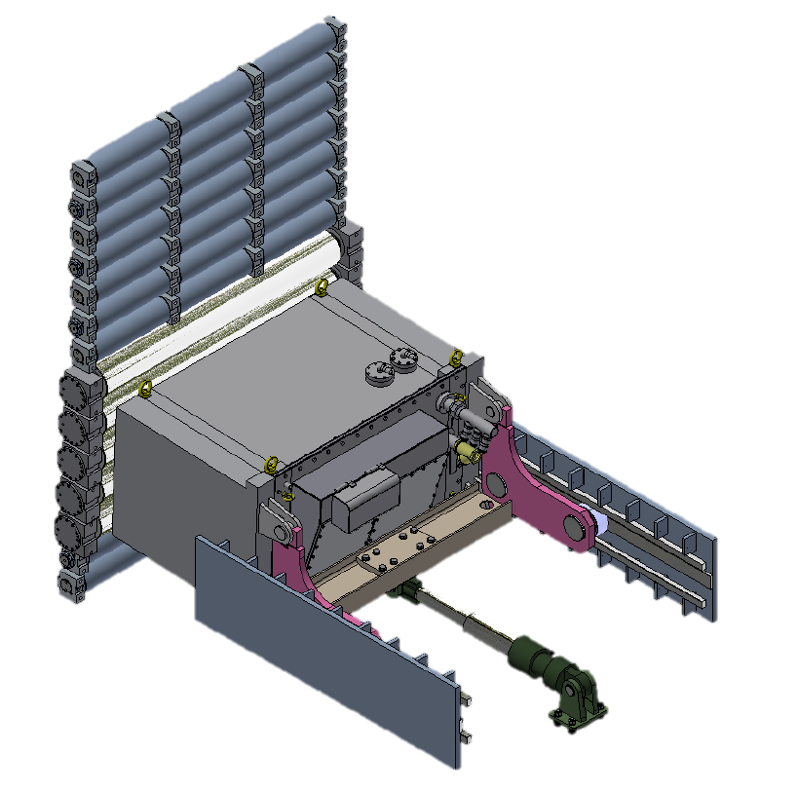

- Typical sketch for reference only -

CB.26.6 Strand guide support structure

Technical Data

|  |  |
| --- | --- |
| Type of design | heavy plate type radial supports and horizontal base frames with provisions for accurate positioning of segments |

Functional Description

The support structure serves as a support of the strand guide segments in the position provided, ensures alignment between segments and transfers the active forces in the strand guide via the bearing stands into the foundation.

Main Components

* Supporting frames
* Segment fixing devices
* Bearing stands for supporting frames including support links
* Self-joining water and air connections

Main Characteristics

* Torsion-free, continuous supporting frame
* Mechanical segment fixation
* Bending zone centering device of stainless steel

Advantages of Design

* Minimized misalignment between adjacent segments
* Exact positioning of individual segments
* Adjustable stainless depositing surfaces for segments
* All contact surfaces between stand guide supporting structure and segments have a stainless weld on as well as stainless steel shims.

Reference Drawing CB.26.6 Strand guide support structure

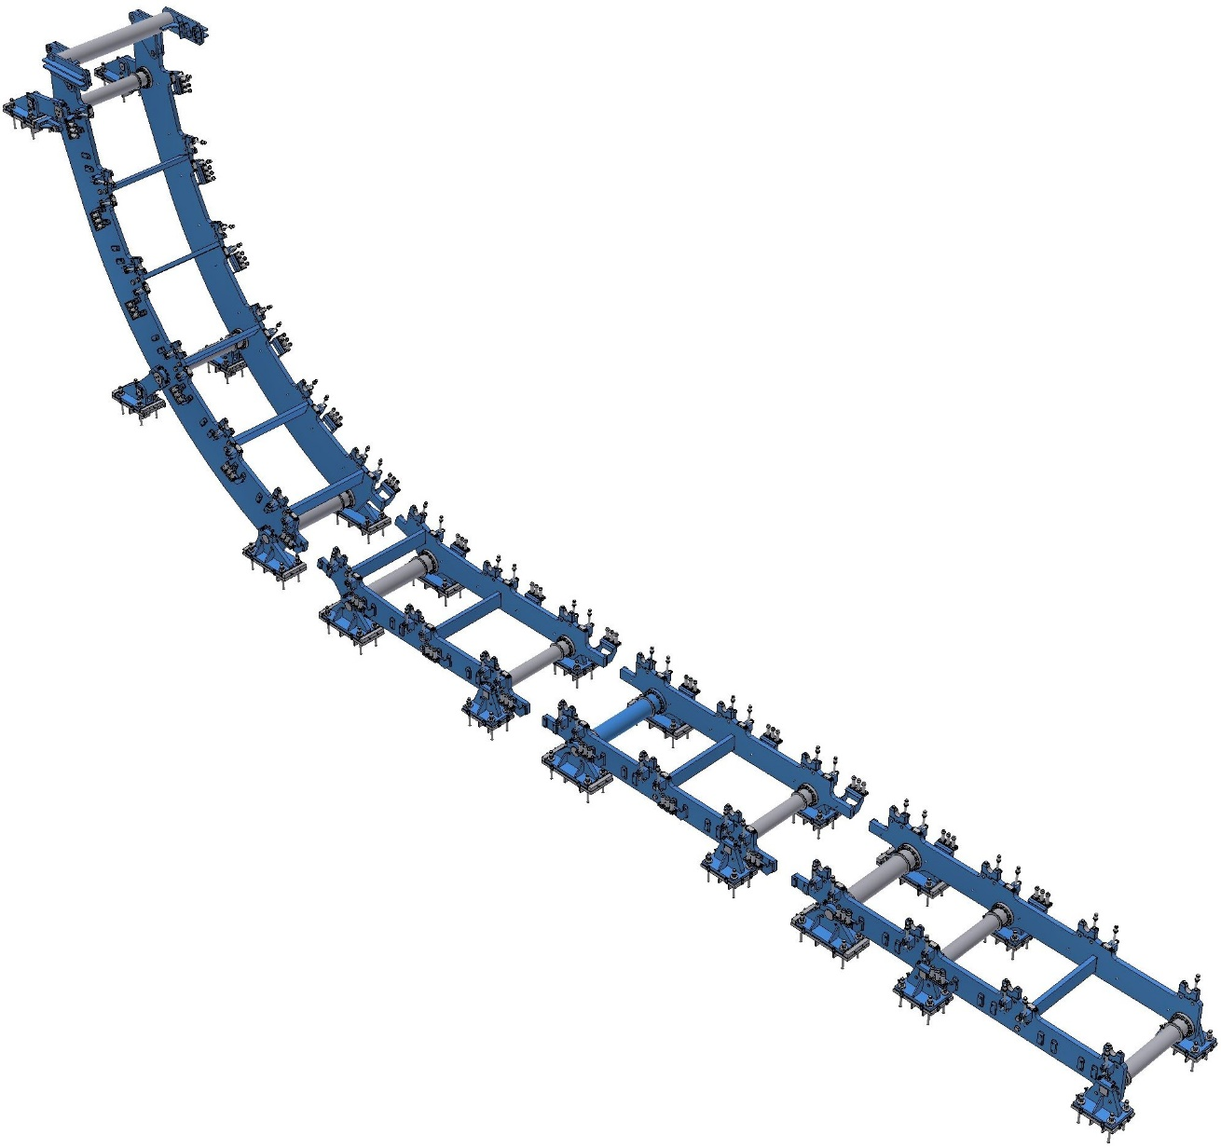

- Typical sketch for reference only –

CB.26.9 Strand guide functions

CB.26.95 Smart Segments (PI)

CB.26.95A Smart Segments position control

Overview

Each positioning device of a strand guide segment is individually controlled by a dedicated Segment Controller. This individual controller is responsible for position control of the segments actual roll gap. The actual roll gap is measured using magnetostrictive position transducers, which are mounted on the related cylinders. The movement is initiated by directional valves, which are controlled by the Segment Controller. Each segment is linked via pluggable connection cable to its Segment Controller. The Segment Controllers are connected to the Process Model and the Process Control System via Ethernet.

For detailed description of Process Model refer to chapter “Process Optimization Level 2”

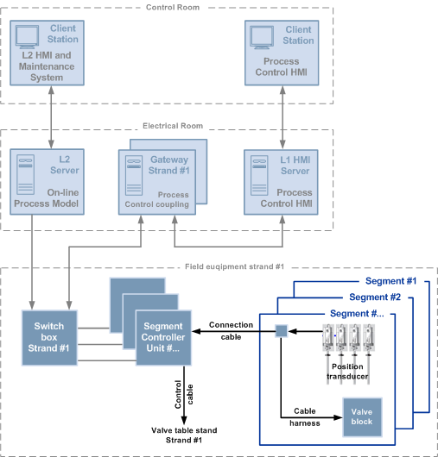  
Schematic overview of the DynaGap Soft Reduction package (for reference only)

Features

Smart Segment Controller

|  |  |
| --- | --- |
| Function | Description |
| General | Segment Controller unit performs the following functions:   * Communication to Process Model (set-points, actual values, status, …) . * Cyclical calculation of the segment gap deviation and position correction individually for the segments DynaGap cylinders. * Segment symmetry monitoring. * Monitoring of position transducer values. * Operation in manual mode with interlocks. * Segment calibration. * Generation of alarm signals.   The segment controller unit supervises the segments movement. Especially, symmetry deviations and inadmissible actual positions are identified and counteracted to avoid segment deflection or structural damage. Alarm messages are generated by the segment controller unit if such conditions occur.  Every segment controller unit allows local manual control of segment movements such as:   * Adjustment of the segment gap * Cold gap adjustment * Operation mode selection   Multi-line color QVGA TFT touch panel display where actual gap values, gap set-point values, important parameters, status and diagnostic information are displayed.  A Segment Controller unit is identified by its local position code number in the strand.  An additional segment identification number is stored inside the sensor electronic head to allow identification of segment. |
| Communication with Process Model | The data exchange with the Process Model is realized via a message based TCP/IP communication protocol using the Ethernet network. |
| Communication with  Process Control | The data exchange with the Process Control HMl is realized via TCP/IP using the Ethernet network. |

|  |  |
| --- | --- |
| Function | Description |
| Calibration | A cold gap adjustment (rough gap calibration) is done to measure construction tolerances of the segment and specify the gap.  The resulting calibration values (offset values) are stored inside the position transducers flash-memory, so that the Segment Controller can retrieve the calibration information.  Individual segment correction values, received from manual measurements by the manual gap checker, are also stored inside the position transducers flash-memory.  Segment calibration can be performed in the maintenance shop or directly on the machine. |
| Position Control | Actual gap positions are detected with magnetostrictive position transducers fitted separately in the positioning DynaGap devices. Position set-point is received from Process Model. Position transducers are working digital, no sensor calibration is necessary.  Using standard hydraulic components (directional hydraulic valves), the positioning DynaGap cylinders are actuated to approach the set-point position. To minimize undesirable valve operation, a hysteresis is defined for position correction.  The segment controller detects symmetry faults and stops individual device movement, if the symmetry fault is outside the tolerance limits. |

|  |  |
| --- | --- |
| Function | Description |
| Emergency Operation | Should one segment controller malfunction, the respective segment remains in the last known position. The segments emergency valve is closed, and gap adjustment is no longer possible until the end of the casting sequence. The Process Model operates the remaining segments in an optimized emergency strategy.  Further emergency functions are:   * In case of position transducer communication failures, the segment will be hydraulically locked by an emergency valve. * All automation functions related to segments are superimposed by hydraulic machine protection measures. * In case of a pressure loss in the hydraulic supply, the emergency valve locks the segment. * UPS Power supply for Segment Controller units. |
| Connection to Segment | Each Segment Controller is connected to its dedicated segment through the Segment Connection Cable with plug (Harting-connector), where the segment related parts (position and pressure transducer, solenoid valves) are attached. |

Technical data

|  |  |
| --- | --- |
| Control System |  |
| Position control accuracy | ± 0.10 mm |
| Max. deviation from position set-point | ± 0.15 mm |
| Control loop cycle time | 40 ms |
| Position set-point processing time | < 5 sec |

|  |  |
| --- | --- |
| Segment Controller |  |
| Type | Microprocessor based, with numeric indication, external and internal calibration capability and self diagnostic |
| CPU | Segment Controller CPU-EDM OEM |
| Addressing | 16 bit |
| Inputs/Outputs | * Digital input 24 VDC * Digital output 24 VDC * Analog input 4-20mA * Analog output 4-20mA * CAN Bus interface * USB host for software update * Ethernet * TFT 5,7” QVGA display, touch screen |

|  |  |
| --- | --- |
| Position Transducer |  |
| Type | Primetals Magnetostrictive Position Transducer |
| Output Signal | CAN-Fieldbus System ISO 11898 |
| Storage of calibration data and device identification | Within integrated non-volatile sensor memory |
| Measuring Range | According segment opening |
| Protection class | Sensor rod with flange IP 67 Sensor head IP 65 (67) |

Equipment

|  |  |
| --- | --- |
| Description |  |
| Segment Attached Equipment (included in mechanical supply) |  |
| Segment Cable Harness “Harting”:   * HARTING HAN-32 flange-connector box (with cover) * CAN sensor cable set (cables with plugs for connection between position sensors and terminal box, CAN Bus termination unit) * Valve cable set (cables with plugs for connection between solenoid valve manifold / pressure transducer on manifold 1 and terminal box) |  |
| Segment Position Sensor:   * Position transducer with memory and CAN-Bus interface * One transducer per positioning cylinder |  |
|  | |
| Segment Related Equipment |  |
| Switch Box incl. Touch Panel   * Gateway Communication Unit * Remote Segment Control (RSC) * Stainless steel box * Optical Ethernet switch * Power distribution for Segment Controller * Centralized HMI with basic remote operation |  |
| Segment Controller:   * SIEMENS CPU EDM OEM * CAN-Bus interface for position transducers * USB host for software update * Ethernet port * Control and indication devices * Power supply unit * TFT – 5,7” QVGA touch screen * Stainless steel box |  |
| Segment Controller Connection Cable:  Cable with heavy-duty plugs to connect Segment Controller and Segment Cable Harness  Protection hose |  |
| Control cable:  For connection between Segment controller & Enable / Soft-Clamping valve at valve table stand |  |

|  |  |
| --- | --- |
| Description |  |
| Maintenance Equipment |  |
| Segment Controller:   * SIEMENS CPU EDM OEM * CAN-Bus interface for position transducers * USB host for software update * Ethernet port * Control and indication devices * Power supply unit * TFT – 5,7” QVGA touch screen * Stainless steel box |  |
| Segment Controller Connection Cable Set:   * Connection Cable with heavy-duty plugs to connect Segment Controller and Segment Cable Harness * Protection hose * Sensor service cable |  |
| Control cable:  For connection between Segment controller & Enable / Soft-Clamping valve | **Buyer’s supply** |
| Gap Checker Set with: (included in mechanical supply)   * Gap Checker measuring device * Measuring range adapter pieces * Calibration tool * Transport case |  |

CB.27. Withdrawal units & exchange device

CB.27.1 Drives for driven rollers

Technical Data

|  |  |  |
| --- | --- | --- |
| Arrangement of drives: |  | |
| Segments | inside | outside |
| Bow Nos. 1 and 2 | 1 | None |
| Bow Nos. 3 to 5 | 1 | 1 |
| Straightener Nos. 1 + 2 | 1 | 1 |
| Horizontal Nos. 1 to 3 | 1 | 1 |
| Motor type | electric motor | |
| Gear | planetary gear | |
| Connection to driven roller | universal joint shaft | |

Functional Description

The drives are provided to transfer the requested casting speed and the withdrawing force required for the hot strand / dummy bar transfer to the driven rollers.

Main Components

* Motors (are part of electric equipment)
* Coupling
* Gear
* Universal joint shaft
* Support structures for segment drives

Main Characteristics

* Drives mounted on base frame outside of cooling chamber

Advantages of Design

* Very good accessibility of drive components for maintenance and repair work
* Clear arrangement of drive components
* Location outside of the humid area

Reference Drawing CB.27.1Drives for driven rollers

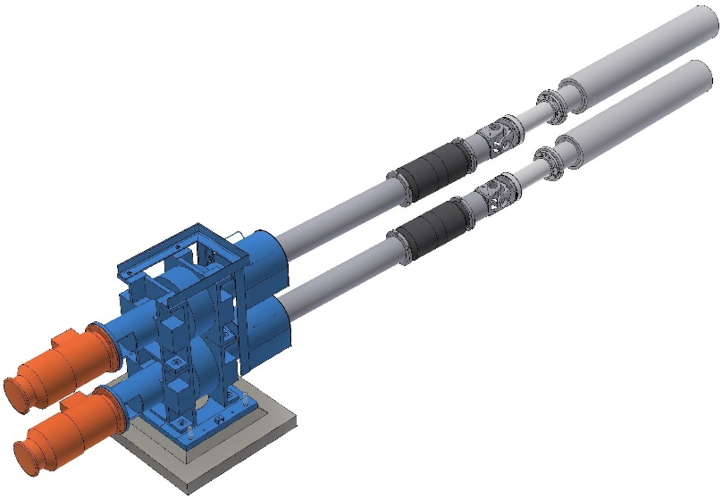

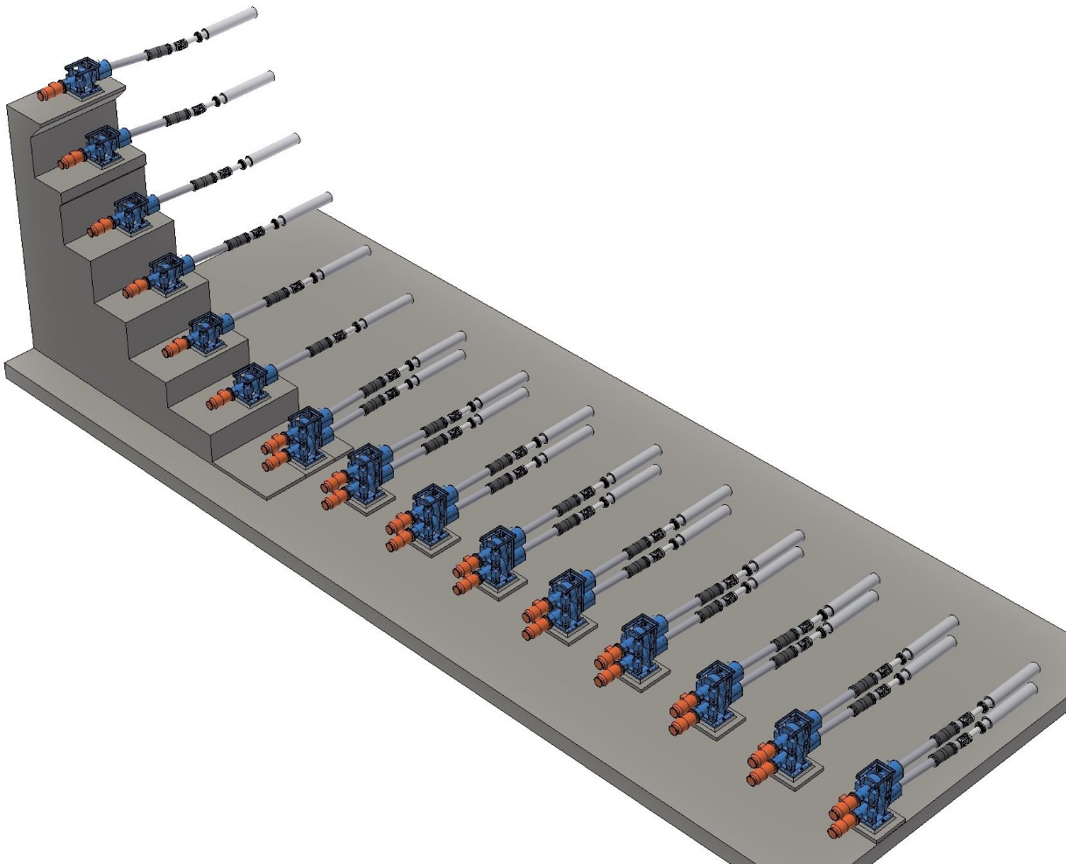

- Typical sketch for reference only –

CB.27.2A Segment manipulator U-shape type (Existing)

Technical Data

|  |  |
| --- | --- |
| Type of design | crosshead with link chain and guides |
| Carrying capacity | limited to 1 segment (heaviest) |

Functional Description

The segment manipulator serves for removal and insertion of segments from / to the machine. The manipulator is handled by the overhead cranes above the casting floor.

Main Components

* U-shaped segment holding frame
* Guide rollers attached to the U-frame
* Segment guide beams

Main Characteristics

* U-shaped supporting frame with lateral guide rollers (the manipulator runs in U-shaped rails)
* Lifting and lowering of manipulator by means of bay crane

Advantages of Design

* Exact positioning of segments by exact guiding of manipulator in the guide rails
* Easy fixation of segment in the manipulator by pins
* Good lateral accessibility of each segment due to the wide construction of the manipulator

Reference Drawing CB.27.2 Segment manipulator U-shape type

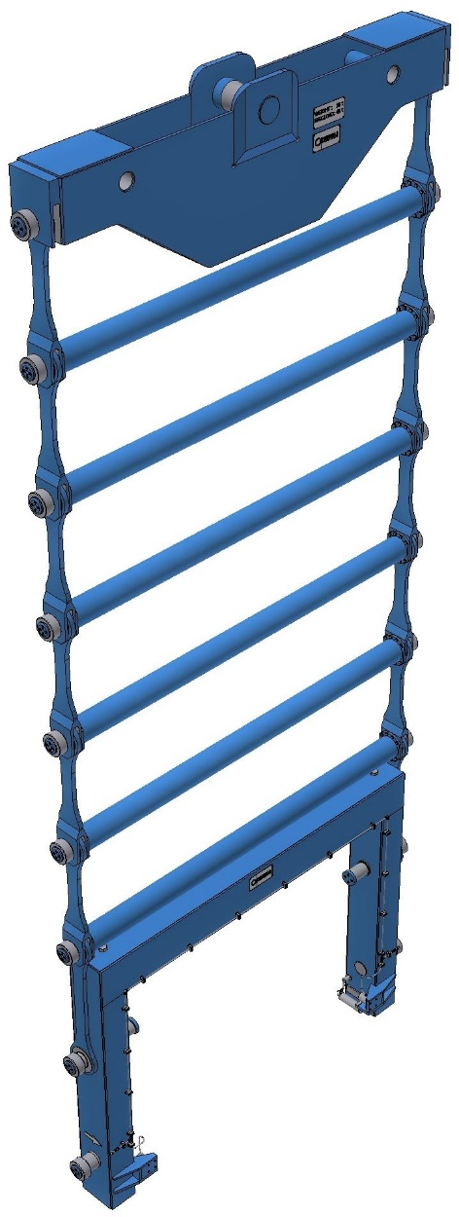

- Typical sketch for reference only –

CB.28 Safety devices

Mechanical Part:

* Safety identification plan, showing dangerous areas, escape routes, safety signs and additionally safety information
* Safety protection covers, where necessary
* Guards (fences, railings and safety doors) to prevent access to hazardous areas

CB.3. Runout area

CB.31. Dummy bar facilities

CB.31.1 Dummy bar

Technical Data

|  |  |
| --- | --- |
| Casting width range: (cold sizes) |  |
| for dummy bar head 1 | approx. 850 – 1.300 mm |
| for dummy bar head 2 | approx. 1230 – 1680 mm |
| Casting thickness, equipped | 220 mm |
| Connection to hot strand | permanent head for automatic disconnection |
| Length of dummy bar | approx. 14m (bottom feeding)  10,2m (top feeding) |
| Thickness of chain | 150 mm (has to be checked by design group) |
| Material: |  |
| for dummy bar head | S355 J2 + N |
| for dummy bar chain and transition part | 42CrMo4V |

Functional Description

The dummy bar and dummy bar head serve to seal the mold for start of casting and to withdraw the hot strand during initial casting. The link type design allows only single-directional bending along the casting bow radius to facilitate easy and simple off-line storage.

Main Components

* Dummy bar chain
* Dummy bar transition part
* Dummy bar head

Main Characteristics

* Dummy bar head designed for cross movement to be centered in the mold

Advantages of Design

* Dummy bar head designed for automatic disconnection from hot strand
* Dummy bar length sufficient to drive dummy bar head above mold cover for inspection or cleaning purposes

Reference Drawing CB.31.1 Dummy bar

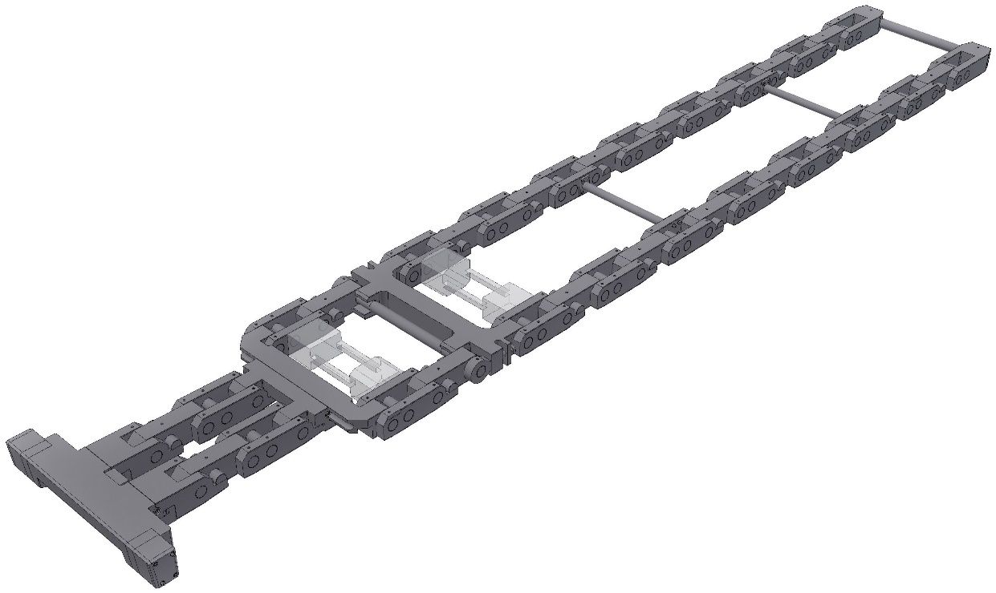

- Typical sketch for reference only –

CB.31.3 Dummy bar receiver

Technical Data

|  |  |
| --- | --- |
| Type of design | bottom feeding system, with car on ramp, depositing area lateral to the roller table |
| No. of cars | 3 |
| Drive | electromechanical |
| Centering of dummy bar | hydraulically operated centering device at roller table area |

Functional Description

The dummy bar receiver transports the dummy bar to and from the centerline of the casting machine discharge roller table. The storage device laterally shifts the complete bar adjacent to the hot strand through an effective „winch and ramp” system.

When feeding the dummy bar, the storage device deposits the bar onto the roller table, which is equipped with a centering device integrally, located at the table. After centering is complete, the bar is ready to be fed into the casting machine via the segment drive rollers.

Main Components

* Runways
* Transfer cars
* Drive unit with motor, gear, shaft, chains and chain wheels
* Centering device with hydraulic cylinder
* Dummy bar head exchange platform

Main Characteristics

* Lifting and lateral movement on inclined runway

Advantage of Design

* Dummy bar head exchange to be carried out on side of the roller table
* Easy maintenance
* Good accessibility

CB.31.5 Storage stand for dummy bar head

Technical Data

|  |  |  |
| --- | --- | --- |
| Type of Construction |  | Steel Structure |
| Capacity |  | All dummy bar heads |
| Location |  | Close to dummy bar receiver |

Functional Description

The dummy bar head storage stand ensures orderly storage of the numerous dummy bar heads.

CB.32. Cutting- & scrap facility

CB.32.1 Torch cutting machine

Technical Data

|  |  |
| --- | --- |
| Type of construction | gantry type |
| Location | downstream of strand guide above torch cutting roller table |
| No. of torches | 2 |
| Sample torches (OPTION) | 2  with automatic sample thickness adjustment (80 to 200 mm) and possible emergency torch replacement |
| Cutting range: |  |
| Slab width | 850 – 1680 mm (Machine Model N)  800 – 3.200 mm (Machine Model L) |
| Slab thickness | 160 - 220 mm (up to 600 mm design range) |
| Slab length: | minimum 5.5 m, maximum 14.0 m |
| Follow-up distance | 9.2 m (will be optimized in accordance to project requirements) |
| Ignition: |  |
| for torch | by integrated ignition flame |
| for ignition flame | By hand match pilot flame by electrical ignition |
| Flame detection | by UV-electrode |
| Granulation | with granulation water nozzles in the cutting area, source in accordance to Chapter CB.4.1 CB.8 Fluids |
| Cutting gas | LPG, technical data please refer to Chapter CB 4.1 CB.8 Fluids |
| Cutting oxygen: | technical data please refer to Chapter CB 4.1 CB.8 Fluids |
| Utility for powder cutting | instrument air or nitrogen |
| Size of cutting powder bin | 50 kg each per burner |
| Length measurement | by measuring roller and position indicator on the torch cutter machine position encoder |
| Mode of operation | Semi-automatic; automatic |

Functional Description

The torch cutting machine serves for cutting the strand to the specified final slab lengths. After the specified slab length has been reached, which is accomplished by an encoder and measuring roller, the torch cutting machine clamps to the hot strand and the cutting process begins.

Upon completion of the cutting procedure, the torch cutting machine automatically returns to its home position and is ready to receive the next desired cut length.

Main Components

* Runway
* Runway girders
* Machine carriage with travelling drive, position indicator and clamping device
* Torch carriages
* Torches
* Cable drag chain including hoses and cables
* Gas control panel for gas and oxygen
* Length measuring device
* Granulation device
* Iron powder devices for stainless steel cutting (OPTION)
* Electrical equipment and software

Main Characteristics

* Cutting machine on rails with runway and runway girders, provided with buffers at the runway ends
* Clamping of cutting machine to the strand prior to start of cutting procedure
* Automatic start of cutting
* Interruption of cutting oxygen supply when passing over the rollers of the roller table
* Utilities supply via cable drag chain
* hand match pilot flame Electrical ignition of pilot flames

Advantages of Design

* Cutting by clamping of torch cutting machine onto the strand
* Protection of rollers by switching off cutting oxygen
* Different home positions can be defined
* Ease of maintenance

CB.32.3 Emergency cutting equipment

CB.32.31 Hand torch cutter

Technical Data

|  |  |
| --- | --- |
| Type of construction | -one portable, manually operated angular torch cutter with skid to ensure safe cutting in the area of torch cutting machine  -one portable, manually operated straight type for cutting in the area of straightener unit and bender/bow segment |
| Application | at torch cutting roller table area  at straightener and bender/bow |
| Length of torch cutter | approx. 3 m for torch cutting area  approx. 2 m for straightener and bender/bow area |
| Utilities supply | via hoses and pressure control station |
| Cutting gas | natural gas, LPG, propane |
| Cutting oxygen: | technical data please refer to Chapter 4.1 CB.8 |
| Nitrogen or instrument air for powder supply for stainless steel |  |
| Dew point | min. -40°C |
| pressure: | min 0.6 MPa |

Functional Description

The hand torch cutters serve for emergency cutting purposes in the torch cutter area as well as in the cooling chamber (strand sticker).

Main Components

* Angular torch cutter/straight torch cutter
* Gas control panel
* Hoses

Main Characteristics

* Torch nozzle of the same type as used at torch cutting machine

CB.32.5 Crop and Scrap removal system

Technical Data

|  |  |
| --- | --- |
| Type of construction | steel structure |
| Length of scrap pieces | up to 1,000 mm |
| Contents | approx. 8 t (depending on size of input) |

Functional Description

The cut scrap ends drop onto the scrap end chute.

The removal of the scrap container will be carried out by crane.

The sample pieces are picked up from the container by using a cover plate. The removal of the cover plate will be done by crane.

Main Components

* Chute
* Container with lifting lugs
* Cover plate

Advantages of Design

* Simple design - welded structure
* No movable parts
* Simple separating and handling of the sample pieces

CB.33. Roller tables

General Technical Data

As far as not specified different at the respective roller table, the data below are applicable:

|  |  |
| --- | --- |
| Roller type | full face roller |
| Roller Diameter | 320 mm (note :up to max 40 t slab weight) 300 mm for slab width > 1800 mm & beyond 40 t slab weight |
| Barrel length | up to max. 1800 mm |
| Roller pitch | refer to layout 2,000 mm |
| Roller table speed | approx. 30 m/min |
| Roller cooling | spray cooling up to one maximum slab length after the torch cutting roller table, afterwards none |
| Bearing type | roller bearing in plummer block |
| Type of motor | Single roller drive with electric gear motor |
| No. of motors | 1 per roller |
| Lubrication | central grease lubrication |
| Slab length | 4,000 – 14,000 mm |
| Slab weight | max. 41t |
| Slab temperature | max. 900°C |
| Slab guides | Lateral guides – where technically possible |

Main Characteristics

* Interchange ability of rollers
* Roller bearings in rigid plummer blocks

Advantages of Design

* Rollers of modular design, thus, low stocking of spare parts
* Quick exchange of rollers if necessary due to modular design of rollers, bearing and motor unit
* In case of motor failure no interruption of operation due to individual motors

CB.33.1 Torch approach roller table

Technical Data

|  |  |
| --- | --- |
| No. of rollers | 3 (incl. 1 disconnecting roller) (for top feeding disconnecting roller is not required!) |
| Roller type | full face roller |
| Roller diameter | 260 mm (valid for all type of roller tables) check 300 mm for slab width > 1800 mm |
| Barrel length | 1800 mm (valid for all type of roller tables) check |
| Roller pitch | 2000 mm |
| Roller table speed | maximum 30 m/min |
| Lifting drive for disconnecting roller | hydraulic cylinder (only for bottom feeding) |
| Bearing type | roller bearing in plummer block |
| Type of motor | electric gear motor |
| No. of motors | 2, disconnecting roller is non-driven |
| Roller cooling | spray cooling on surface |
| Lubrication | central grease lubrication |

Functional Description

The torch approach roller table serves to support the dummy bar and hot strand down to the discharge area.

During casting the rollers are idle.

Disconnection of dummy bar from hot strand is accomplished by means of disconnecting roller. (Only for bottom feeding, no disconnecting roller for top feeding)

Main Components

* Roller table frame
* Rollers with bearings
* Motor unit per driven roller
* Dummy bar disconnecting device
* Machine attached piping for all utilities

Main Characteristics

* Interchange ability of rollers
* Roller bearings in solid plummer blocks

Advantages of Design

* Rollers of modular design, thus, min. stocking of spare parts
* Quick exchange of rollers if necessary due to modular design of rollers, bearing and motor unit
* In case of motor failure no interruption of operation due to individual motors

Reference Drawing CB.33.1 Torch approach roller table

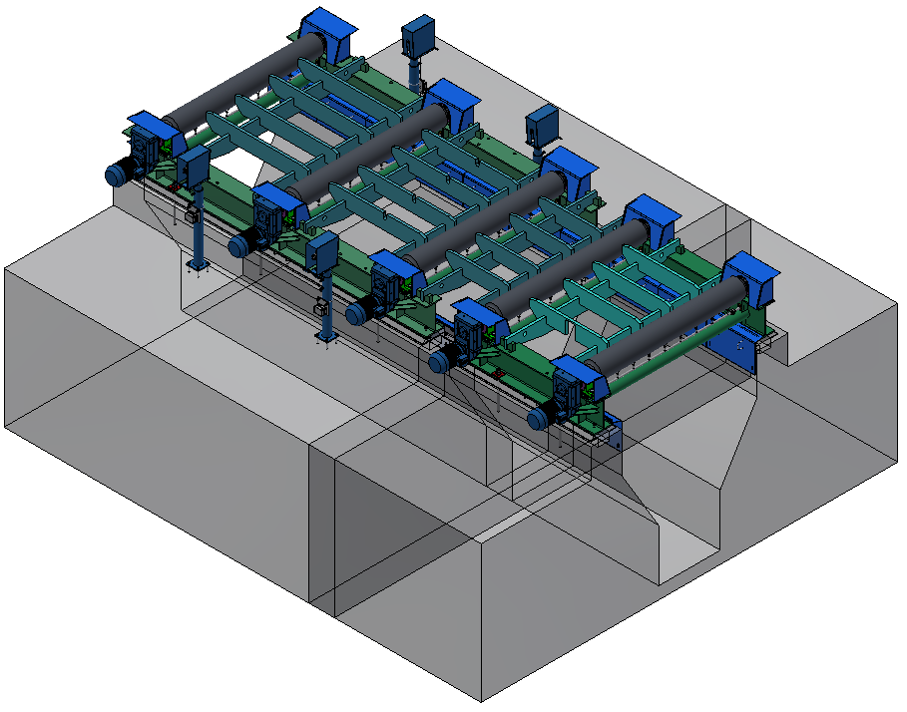

- Typical picture for reference only -

CB.33.2A Torch cutting roller table

Technical Data

|  |  |
| --- | --- |
| Type of construction | shift able roller table |
| No. of rollers | 5, driven |
| Roller type | full face roller |
| Roller pitch | 2000 mm |
| Roller table speed | maximum 30 m/min |
| Bearing type | roller bearing in plummer block |
| Type of motor | electric gear motor |
| No. of motors | 4 |
| Shifting drive | hydraulic cylinder |
| Shifting distance | 600 mm |
| Roller cooling | spray cooling |
| Lubrication | central grease lubrication |

Functional Description

The torch cutting roller table serves to transfer the dummy bar and hot strand to the torch cutting area.

When the torch arrives at the roller area the roller table is shifted and the cutting oxygen supply of the torch cutter is shut off at the same time.

The driven rollers run synchronously to the casting speed (free running) or at roller table speed (roller motor) upon completion of cutting.

Main Components

* Shift able roller table frame
* Stationary guide rollers with supporting structure
* Shifting mechanism
* Rollers with bearings
* Motor unit
* Machine attached piping for all utilities
* Spray protection
* Cutting slag collection chute

Main Characteristics

* Shift able roller table to prevent roller damage
* Interchange ability of rollers

Advantages of Design

* Rollers of modular design, thus, min. stocking of spare parts
* Quick exchange of rollers if necessary due to modular design of rollers, bearing and motor unit
* In case of motor failure no interruption of operation due to individual motors

Reference Drawing CB.33.2A Torch cutting roller table

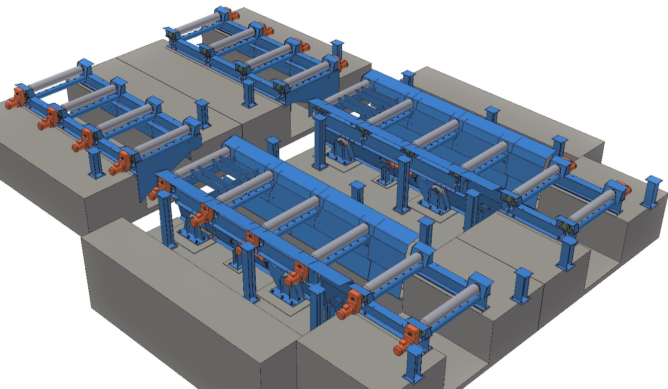

- Typical picture for reference only -

CB.33.3 Runout roller table

Technical Data

|  |  |
| --- | --- |
| No. of rollers | please refer to layout |
| Roller type | full face roller |
| Roller pitch | 2000 mm |
| Roller table speed | approx. 30 m/min |
| Bearing type | roller bearing in plummer block |
| Type of motor | electric gear motor |
| No. of motors | 1 per roller |
| Roller cooling | spray cooling up to one maximum slab length after the torch cutting roller table |
| Lubrication of roller bearings | central grease lubrication (first 6 rollers) / all others manually greased |
| Slab temperature | max. 900°C |

Functional Description

The run out roller table split into several groups serves to support and transport the hot strand to the final discharge area.

The driven rollers are operated at the roller table speed specified.

Main Components

* Roller table frame
* Rollers with bearings
* Motor unit per roller

Main Characteristics

* Interchange ability of rollers
* Roller bearings in rigid plummer blocks

Advantages of Design

* Rollers of modular design, thus, low stocking of spare parts
* Quick exchange of rollers if necessary due to modular design of rollers, bearing and motor unit
* In case of motor failure no interruption of operation due to individual motors

CB.33.4 Weighing roller table with weighing grid (ALTERNATIVE)

Technical Data

|  |  |
| --- | --- |
| Type | hydraulically operated weighing grid |
| Max.slab weight | approx.40 t |
| Lifting stroke | approx. 140 mm |
| Lifting drive | hydraulic cylinder |
| No. of rollers | 6 |
| Roller type | full face roller |
| Scale | via load cells (see electric part) |
| Roller pitch | 2000 mm |
| Roller table speed | approx. 30 m/min |
| Bearing type | roller bearing in plummer block |
| Type of motor | electric gear motor |
| No. of motors | 1 per roller |
| Lubrication of roller bearings | manually greased |
| Slab temperature | max. 900°C |

Functional Description

The slabs are transferred from the run out table to weighing roller table to weighing position.. The weighing grid lifts the slabs by hydraulic cylinder for weighing. After the system becomes still the weight of the slabs is recorded and the grid lowers the slabs onto the weighing roller table for further transportation.

Main Components

* Base frame
* Weighing grid
* Grid lifting mechanism
* Hydraulic cylinder
* Load cells
* Roller table frame
* Rollers with bearings
* Motor unit per roller

Main Characteristics

* Lifting the slabs from roller table for weighing

Advantages of Design

* Lower load for load cells

CB.33.5 Discharge roller table (ALTERNATIVE)

Technical Data

|  |  |
| --- | --- |
| No. of rollers | please refer to layout |
| Roller type | full face roller |
| Roller diameter | 260 mm 300 mm for slab width > 1800 mm  or for slab width < 1800 mm in case of crane pick up |
| Roller pitch | 2000 mm |
| Roller table speed | approx. 30 m/min |
| Bearing type | roller bearing in plummer block |
| Type of motor | electric gear motor |
| No. of motors | 1 per roller |
| Lubrication of roller bearings | manually greased |
| Slab temperature | max. 900°C |

Functional Description

The discharge roller table serves to support and transport the hot strand from the run out area to the final roller table area e.g. for crane pick up of the slab.

The driven rollers are operated at the roller table speed specified.

Main Components

* Roller table frame
* Rollers with bearings
* Motor unit per roller

Main Characteristics

* Interchange ability of rollers
* Roller bearings in rigid plummer blocks

Advantages of Design

* Rollers of modular design, thus, low stocking of spare parts
* Quick exchange of rollers if necessary due to modular design of rollers, bearing and motor unit
* In case of motor failure no interruption of operation due to individual motors

Reference Drawing CB.33.5 Discharge roller table

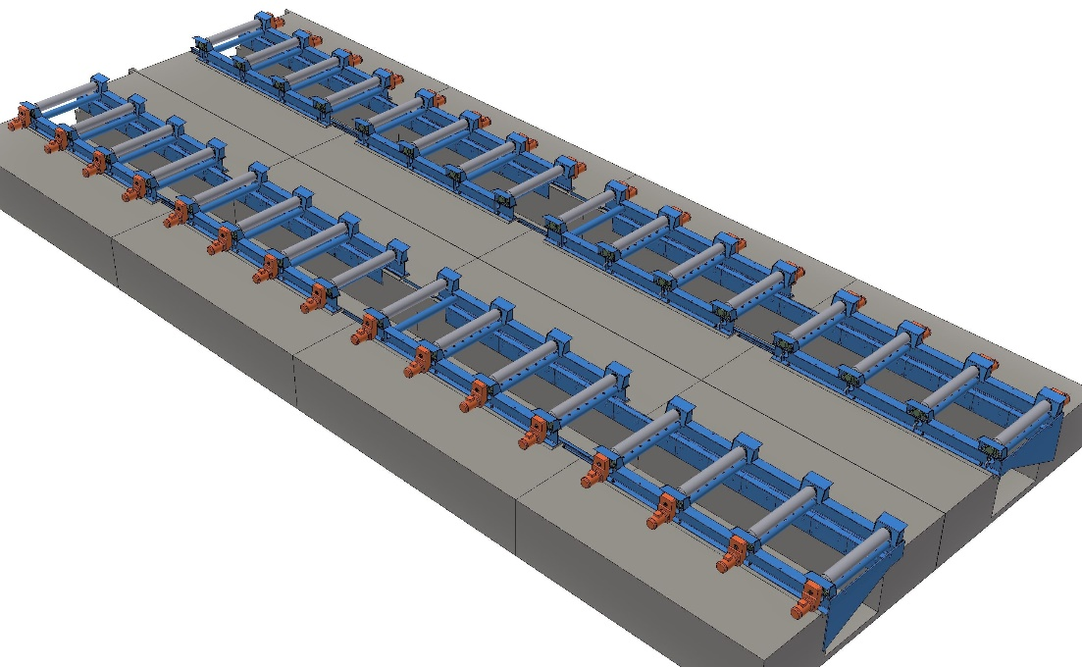

- Typical picture for reference only -

CB.34. Roller table auxiliaries

CB.34.1 Movable stop (ALTERNATIVE)

Will be done only with light barriers

Technical Data

|  |  |
| --- | --- |
| Max. slab weight | approx. 40 t |
| Max. impact speed | 30 m/min |
| Stroke | hydraulic cylinder |
| Stop | continuous beam |
| Impact absorption | spring assembly |

Functional Description

The movable stop serves to position the dummy bar at the depositing area and the slabs in the discharge area.

The stop is lifted by hydraulic cylinder into the top end position.

The stop is lowered before transport of slabs is continued.

Main Components

* Base frame with stop beam and spring assemblies
* Hydraulic lifting device

Main Characteristics

* The design of the stop is for the max. impact energy specified

Reference Drawing CB.34.1 Movable stop

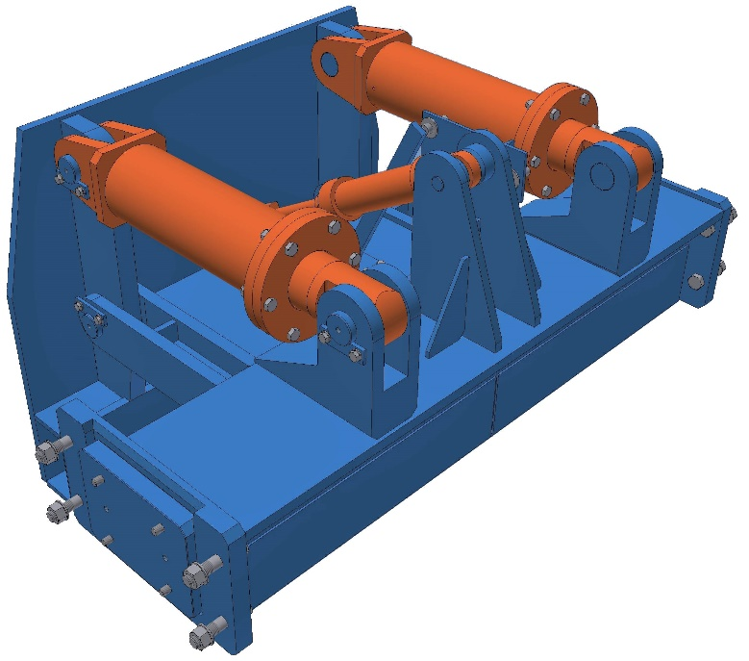

- Typical picture for reference only -

CB.34.2 Fixed stop

Technical Data

|  |  |
| --- | --- |
| Max. slab weight | approx. 41t |
| Max. impact speed | 30 m/min |
| Impact absorption | spring assembly |
| Stop | continuous stop beam |

Functional Description

The fixed stop is located at the end of the roller table and stops the slab at roller table end.

Main Components

* Base frame with stop beam and spring assemblies

Main Characteristics

* The design of the stop is for the max. impact energy specified

Reference Drawing CB.34.2 Fixed stop

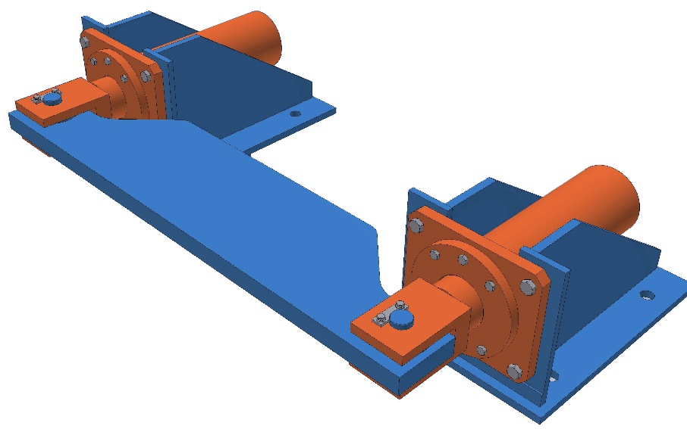

- Typical picture for reference only -

CB.34.5 Strand tracking systems

The Strand Tracking System consists of support structure, protection plates and piping for cooling of the light barriers.

For the Functional description of Strand Tracking Systems please refer to CB.9 Electric, Instrumentation and Automation.

CB.35. Deburring- & marking facilities

CB.35.1A Rotary type deburrer (OPTION)

Technical Data

|  |  |
| --- | --- |
| Type of construction | mechanical operated - rotary type |
| Deburring | during passing at roller table speed |
| Drive: |  |
| rotor drive | by electric motor |
| rotor lifting | hydraulically |
| Slab temperature | 500 - 900°C |
| Burr disposal | collecting box via chute |
| Utility supply | hydraulic |

Functional Description

The deburrer serves to remove the burr at the head end and tail end of each slab. The rotor is lifted and the hammers hit the bottom side of the slab, so that the burr is removed during passing.

Main Components

* Base frame with lifting device
* Rotor with hammers
* Component piping
* Housing of deburrer

Main Characteristics

* Hydraulic adjustment of rotor
* Deburring during passing at roller table speed

Advantages of Design

* On-line deburring

CB.35.2 Burr discharge chute (OPTION)

Technical Data

|  |  |
| --- | --- |
| Type of construction | chute with container |

Functional Description

The burr drops via chute into the container located beneath the burr remover.

Main Components

* Chute
* Container

CB.35.4B Metal wire/ powder marking machine (OPTION)

Technical Data

|  |  |
| --- | --- |
| Type | Wire / powder-spray marking machine (to be confirmed during detail engineering) |
| Marking position | on slab narrow side / on slab front face (but not for SS!) |
| Symbol size | 60 - 150 mm possible, however equipment supply only for one size, which has to be defined later |
| No. of symbols | 14 minimum (max to be confirmed) |
| Marking time | 6 sec per symbol |
| Possible symbols | alphanumeric |
| Surface descaling | mechanical |
| Slab temperature | 500 – 1200°C (depending on final chosen type) |
| Marking material | aluminium wire / aluminium oxide powder (Al2O3)  (depending on final chosen type) |
| Utility | oxygen, compressed air and gas |

Functional Description

The marking machine serves to mark the slabs for identification purposes.

The marking machine approaches the slab and descales the slab surface. Subsequently, the number/letter codes pre-set by the computer or by the operator are sprayed onto the slab.

Main Components

* Frame
* Descaling unit
* Marking unit
* Utility supply piping

Main Characteristics

* Automatic positioning at the slab face
* Mechanical descaling

Advantages of Design

* Large marking symbols and therefore, readability from a greater distance

CB.36. Piling & transfer facilities (OPTION)

Bemerkung : 361A bis 364A : “Standardausführung” mit hydraulischem Gleichlauf

CB.36.1A Piler pusher (Option) (hydr. Synchronism / OPTION)

Technical data

|  |  |
| --- | --- |
| Type | hydraulically operated |
| Slab Length | 4000 - 14000 mm |
| Slab weight | max. 40 t |
| Pushing stroke | approx. 3000 mm (for Slab 1600 mm wide)  approx. 3600 mm (for Slab 2200 mm wide) |
| Number of pusher carriages | 2 (connected by a pusher rod) |
| No. of hydraulic cylinder | 2 |
| Hydraulic cylinder stroke | approx. 1500 mm |
| Pushing speed | forward/backward approx. 120 mm/sec. |
| Cylinder speed | forward/backward approx. 60 mm/sec. |
| Slab Temperature | max. 900 °C |

Functional Description

The slab pusher serves for pushing the slabs from roller table to the piler table. The runways for guiding the pusher carriage are mounted on the roller table. The pusher carriages are connected by a pusher rod.

Main Components

* Base frame
* Runways
* Levers with pusher carriages
* Hydraulic cylinders
* Heat protection covers
* Electrical and hydraulic control system
* Utility supply piping

Main Characteristics

* Two hydraulically driven pusher carriages

Advantages of Design

* Overload protection by hydraulic excess pressure protection
* Arrangement of a pusher rod allows for operating of short, as well as long slabs

Reference Drawing CB.36.1A Piler pusher

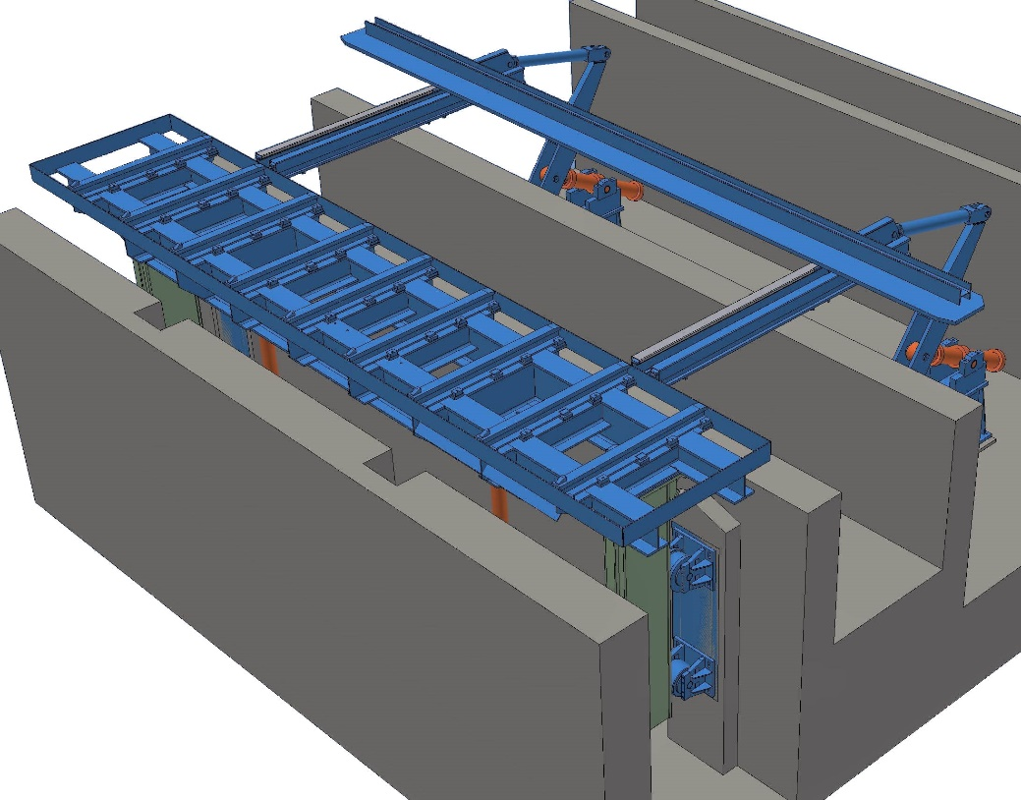

- Typical picture for reference only -

CB.36.2A Piler table (Option) (hydr. Synchronism / OPTION)(hydr. Synchronism / OPTION)

Technical Data

|  |  |
| --- | --- |
| Type | hydraulically operated lifting table |
| Slab Length | 4000 - 14000 mm |
| Pile weight | max. 110 t (to be confirmed by JSL, depends on bay tong crane) |
| Lifting stroke | 900 mm(3 x Slab thickn.+ warpage + 100mm) |
| Number of slabs to be piled | max. 3 |
| Number of hydraulic cylinder | 2 |
| Lifting / lowering speed | approx. 30 mm/sec |
| Slab temperature | max. 900 °C |

Functional Description

The piler table serves for piling a pile of hot slabs pushed out from the roller table by piler pusher. After one slab is pushed onto the piler table the table is lowered by one slab thickness, until the top surface of the slab is detected. Stroke control is done by light barriers in combination with a distance transducer. After piling is finished, the piler is lifted to the top position and the bay tong crane picks up the pile, and the next piling sequence can be started

Main Components

* Base frame
* Table frame with vertical guidance system
* Hydraulic cylinders
* Heat protection covers
* Electric and hydraulic control system
* Utility supply piping

Main Characteristics

* Automatic positioning of stroke movement by light barriers in combination with a distance transducer

Advantages of Design

* Operation independent of the slab thickness and slab shape
* Overload protection by hydraulic excess pressure protection

Reference Drawing CB.36.2A Piler table

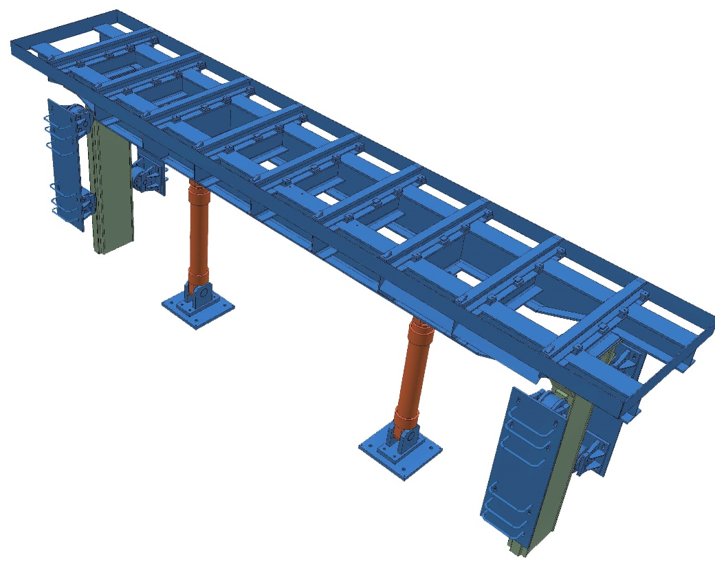

- Typical picture for reference only -

CB.38 Safety devices

Mechanical Part:

* Safety identification plan, showing dangerous areas, escape routes, safety signs and additionally safety information
* Safety protection covers, where necessary
* Guards (fences, railings and safety doors) to prevent access to hazardous areas

CB.4. Slab handling

CB.42. Inspection facilities

General description

A small part of slab production which deviates from the production conditions (defined as not hot chargeable) and/or are first slabs of a sequence and/or quality change slabs have to be cooled down to inspection /hand scarfing/hand grinding temperature.

Inspection slab temperature max. 200° C. Slab cooling will be done mostly by air cooling in piles.

CB.42.1 Inspection grate

Technical Data

|  |  |
| --- | --- |
| Type of design | bottom grate inspection grate |
| Material | scrap slabs (customer supply) |
| Length | approx. 15,000 mm |
| Width | approx. 6,000 mm |
| No of slab places | 4 |
| Scale discharge/cleaning | manually by hand or by crane magnet device |
| Slab turning over for inspection lower slab surface | by bay magnet crane or slab turnover device |

Functional Description

The inspection grate is made of scrap slabs and is used for slab inspection.

CB.42.2 Inspection steel structure

Technical Data:

|  |  |
| --- | --- |
| Type of design | steel structure protection wall |
| Height | approx. 2,500 mm |
| Length | approx. 15,000 mm |
| Media supply | oxygen and gas for hand scarfing electricity for hand grinding |
| Take over point | next column |

Main Components:

* Protection wall for protection of surrounding equipment and bay wall / columns.
* Base frame steel structure for gas regulation stations for hand scarfer
* Interconnecting piping for media or cabling for hand grinding

CB.42.3 Hand scarfing device (Existing)

Technical Data

|  |  |
| --- | --- |
| Type | hand-operated with flow regulating valve |
| Scarfing width | 100 to 150 mm |
| Scarfing depth | 2 - 5 mm |
| Length of blow pipe | approx. 1,200 mm |
| Length of hoses | approx. 14 m |
| Scarfing ignition | automatically by starting wire |

Utilities consumption (peak consumption/scarfing burner):

|  |  |
| --- | --- |
| Oxygen (min. 12 bar) | 150 – 190 Nm³/h |
| COG (purified) | approx. 10 Nm³/h |

Functional Description

The hand scarfers are used in the inspection and conditioning area for removing the small slab surface defects.

Main Components

* Hand scarfing torch with hoses
* Gas regulation station

CB.42.4 Hand grinding device (Existing)

Technical Data

|  |  |
| --- | --- |
| Type of design | hand held grinding unit |
| Drive | electrically or pneumatically |

Functional Description

The hand held grinding units are used in the inspection and conditioning area for removing small slab surface defects.

Main Components

* Hand grinding units
* Cables / Hoses

CB.42.5 Slab turning device (Existing)

Technical Data

|  |  |
| --- | --- |
| Type | hydraulically actuated 2 shaft turnover |
| No. of turning arms | 2 x 4 |
| No. of depositing grates | 2 x 4 |
| No. of hydraulic cylinders | 2 x 2 |
| Turning direction | forward grate 1 to grate 2 |
| Turning time | min. 180 sec. |
| Slab weight | max. 40 t |
| Slab length | 5,000 – 12,000 mm |
| Slab temperature | max. 900 °C |

Functional Description

The slab turnover tilts the slab by 180° for slab inspection of lower wide side slab surface. Slabs, which have to be tilted, are placed on the depositing grate No.1 by bay crane (or by magnet crane for cold slabs). The turnover tilts the slab automatically from grate 1 to grate 2. After turning, the slab can be picked up by bay tong crane.

Main Components

* Base frame
* Connection shafts with turning arms and buffers
* Depositing / pick up grates
* Hydraulic cylinders
* Heat protection covers
* Hydraulic control system
* Interconnecting piping
* Central lubrication and media piping
* Electrical control system (see electrical part)

Main Characteristics

* Automatically slab turning

Advantages of Design

* Mechanical synchronization of turnover arms by shaft.
* Shock less turnover operation with low noise

CB.48 Safety devices

Mechanical Part:

* Safety identification plan, showing dangerous areas, escape routes, safety signs and additionally safety information
* Safety protection covers, where necessary
* Guards (fences, railings and safety doors) to prevent access to hazardous areas

CB.5. Peripheral Facilities

CB.51. Maintenance stands

General Description of Maintenance Facilities

Mold Maintenance

Mold maintenance, alignment and testing are carried out at the **Mold Alignment Stand**.

Prior to installation in the casting machine, each of the molds have to be maintained to ensure proper alignment and function.

The maintenance work is carried out in following steps:

* Assembly / disassembly, repair work
* Alignment of copper plates and foot rollers
* Water pressure test, test of hydraulic functions and lubrication check
* Calibration of narrow side adjustment device

After maintenance the mold is stored at the ground floor.

Mold Oscillator Maintenance

Mold oscillator maintenance, alignment and testing is carried out at the **Maintenance Stand for Oscillator**.

Prior to installation in the casting machine, the oscillator unit has to be maintained to ensure proper alignment and function.

The maintenance work is carried out in following steps:

* Assembly / disassembly, repair work
* Alignment of mold table
* Test of oscillation movement
* Water pressure test

After maintenance the oscillator unit is stored at the **Storage Stand for Oscillator**

Bender Maintenance

Bender maintenance, alignment and testing is carried out at the **Bender Alignment Stand**.

Prior to installation in the casting machine, each of the benders have to be maintained to ensure proper alignment and function.

The maintenance work is carried out in following steps:

* Turning of the bender from vertical to horizontal by bender turning stand
* The Bender is transferred to the Bender Maintenance & Aligning Stand
* Disassembly of inner bow from outer bow at the Bender Maintenance & Aligning Stand
* The inner bow is transferred to and tilted at Bender Turning Stand
* Disassembly / assembly and alignment of inner and outer bow rollers at the **Bender Alignment Stand**
* Reassembly of bender and check the roller gap at the **Bender Alignment Stand**
* Turning of the reassembled bender from horizontal to vertical by bender turning stand
* Nozzle spray test at the **Water Test Stand**

After maintenance the bender is stored at the ground floor.

Smart Segment Maintenance

Smart Segment maintenance, alignment and testing is carried out at the **Segment Alignment Stand for Entire Segment**.

Prior to installation in the casting machine, each of the segments have to be maintained to ensure proper alignment and function.

The maintenance work is carried out in following steps:

* Disassembling / assembly of segment inner bow at the **Segment Alignment Stand for Entire Segment**
* Turning of the segment inner bow by 180 degree at the **Segment Inner Bow Turning Stand**
* Disassembly / assembly and alignment of the inner bow rollers at the **Segment Alignment Stand for Inner Bow**
* Disassembly / assembly, alignment of outer bow rollers at the **Segment Alignment Stand for Entire Segment**
* Reassembly of outer and inner bow, check of roller gap, test of hydraulic functions and lubrication at the **Segment Alignment Stand for Entire Segment** via the **Inner Bow Turning Stand**
* Water pressure test and nozzle spray test at the **Water Test Stand**

After maintenance the segment is stored at the ground floor.

CB.51.1 Alignment stands

CB.51.11 Mold alignment stand (Existing)

Technical Data

|  |  |
| --- | --- |
| Stand capacity | 1 mold |
| Water supply | from service water system |
| Test pressure |  |
| spray test | max. 0.6 MPa |
| tightness test | max. 1.2 MPa |
| Hydraulic supply | via hydraulic power unit for machine maintenance |

Functional Description

The stand serves for

* Test of tightness of water system
* Spray nozzle test
* Test of wide side unclamping
* Test of narrow side adjustment
* Repair and assembly work (Cu plate set, foot and lateral strand guide rollers), as well as for adjusting and checking work.
* Calibration of narrow side adjustment device

Main Components

* Mold supporting frame with water supply, centering and fixing device (for simulation of mold table)
* Reference surface for pre-setting of transition mold foot roller to bender
* Measuring surface (CB.51.112/possible installation of an additional unit on the casting platform in the area close to the mold)
* Platforms, railings, stairs
* Electrical pressure test pump (please refer to Chapter 4.1 CB. 8)
* Test unit (WAMBoy) for narrow side adjustment test (please refer to Chapter 4.2 CB. 9)
* Lifting tools for easy assembly work of foot and lateral strand guide rollers

Main Characteristics

* Self joining water connecting on placing

Advantages of Design

* Facilitation of work due to functional accessibility

Reference Drawing CB.51.11 Mold Alignment Stand

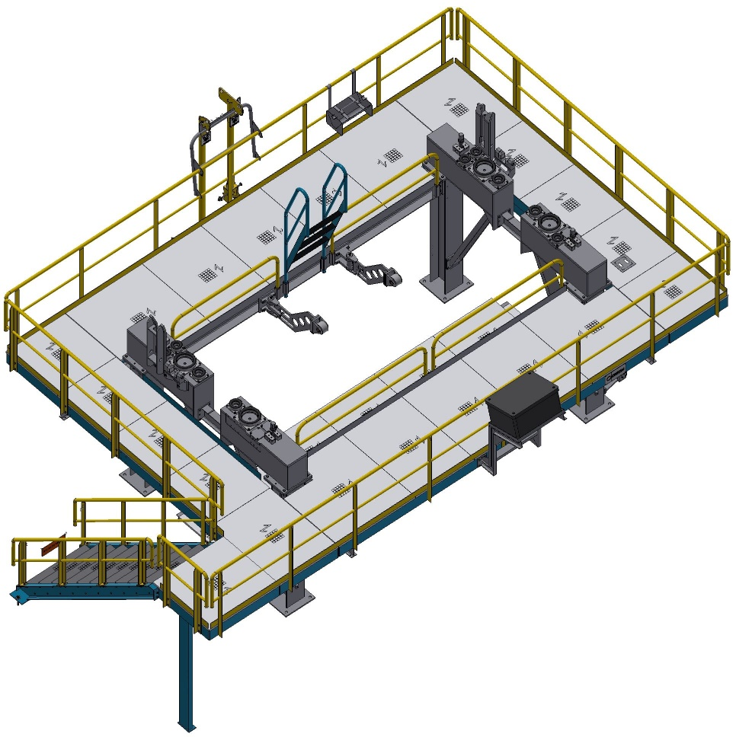

- Typical sketch for reference only –

Reference Drawing CB.51.11 Lifting tools

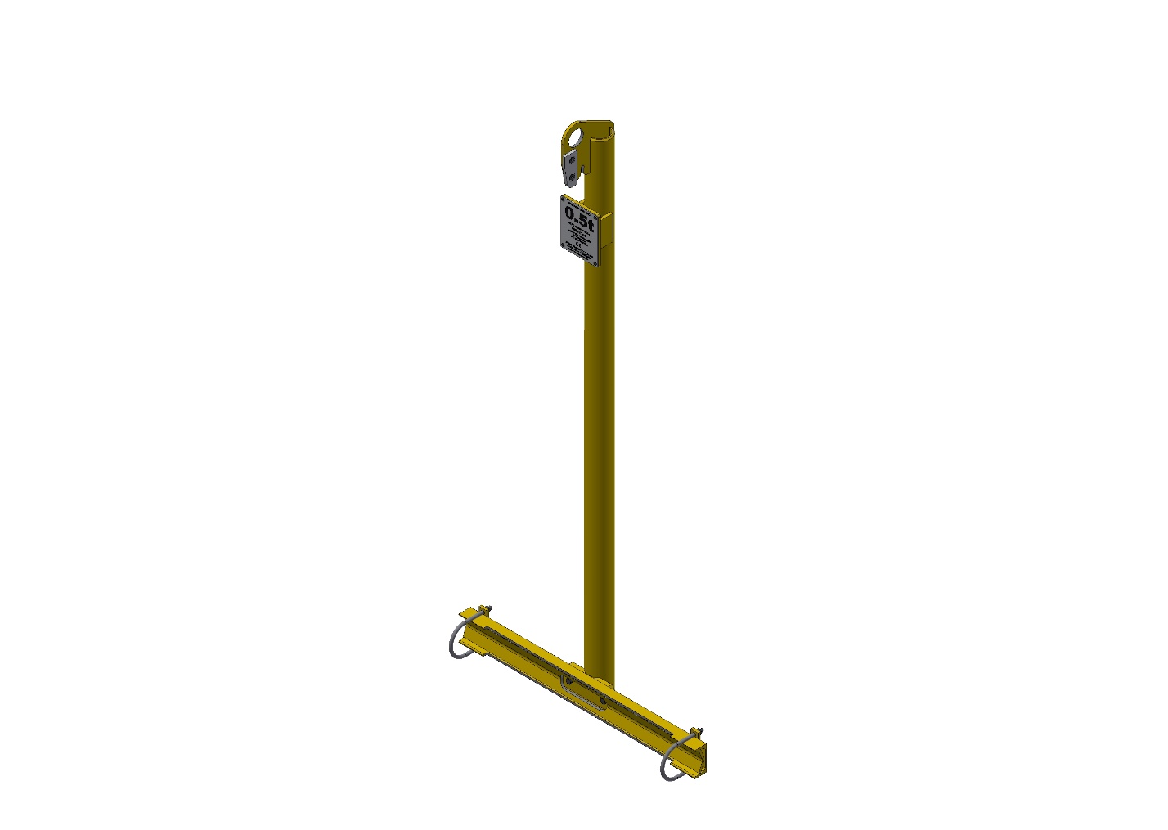 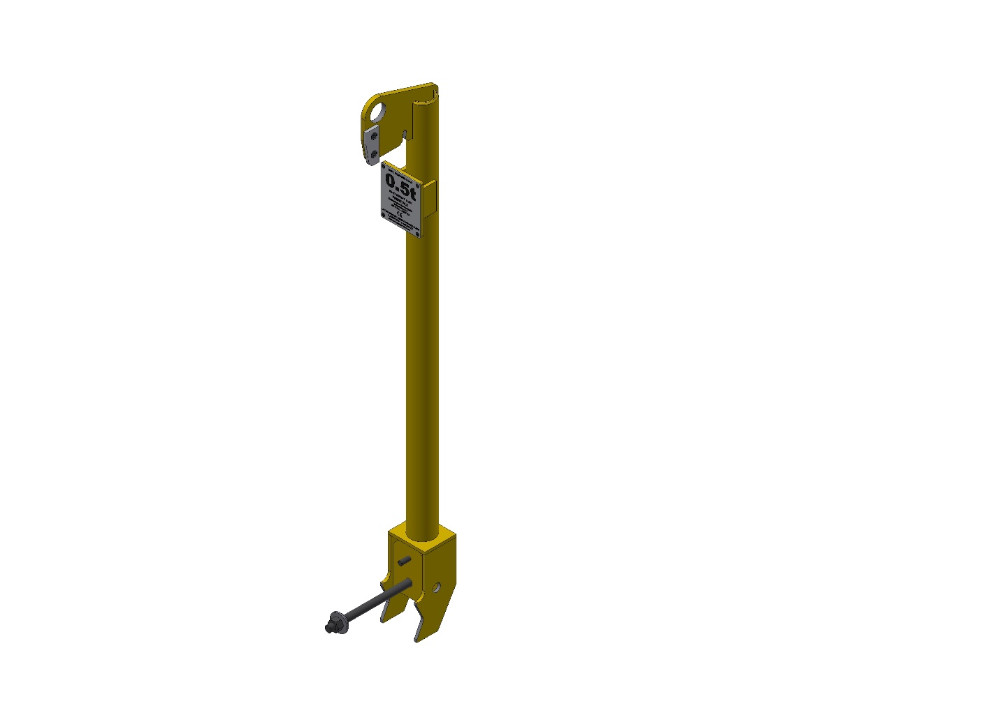

- Typical sketch for reference only –

CB.51.12 Maintenance stand for oscillator (Existing)

Technical Data

|  |  |
| --- | --- |
| Stand capacity | 1 oscillating unit |
| Water supply | from service water system of mold alignment stand |
| Water test pressure | 1.2 MPa |
| Hydraulic supply | via hydraulic power unit for machine maintenance |

Functional Description

The test stand serves for

* Repairs and assembly work
* Test of the movement of the oscillation
* Test of tightness of water system

Main Components

* Supporting structure with supporting surfaces
* Test unit (OsciBoy) for movement test (please refer to Electric & Automation)

Advantages of Design

* Adjustment of oscillator and testing of movement of the oscillation unit in the maintenance area
* Self joining water connection on placing

Reference Drawing CB.51.12 Maintenance stand for oscillator

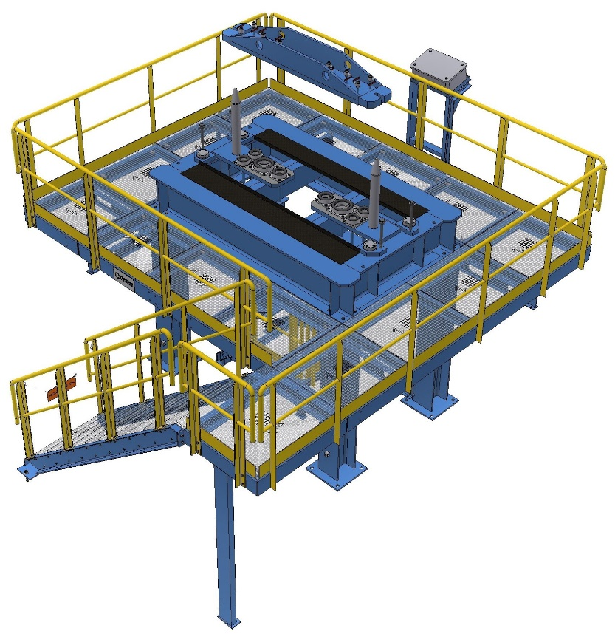

- Typical sketch for reference only –

CB.51.13 Bender alignment stand (Existing)

Technical Data

|  |  |
| --- | --- |
| Stand capacity | 1 bender |

Functional Description

The stand serves to check the roller position at the inner bow and outer bow as well as to check the frame structure for dimensional accuracy.

Main Components

* Base frame with support brackets
* Centering guide
* Reference measuring surfaces
* Platforms and stairs
* Straight ruler (only if OPAL is not installed!)  
  Note: use of rulers requires also INA-rails for ruler support and machined steel structure with supporting frame

Main Characteristics

* Reference supporting surfaces for simulation of supports in the machine
* Clear and easily accessible adjusting stand

Advantages of Design

* Easy and simple adjusting and checking with measuring device
* Measurement of roller alignment at any point over the full width possible
* Easy roller manipulation due to access from top

Reference Drawing CB.51.13 Bender Alignment Stand

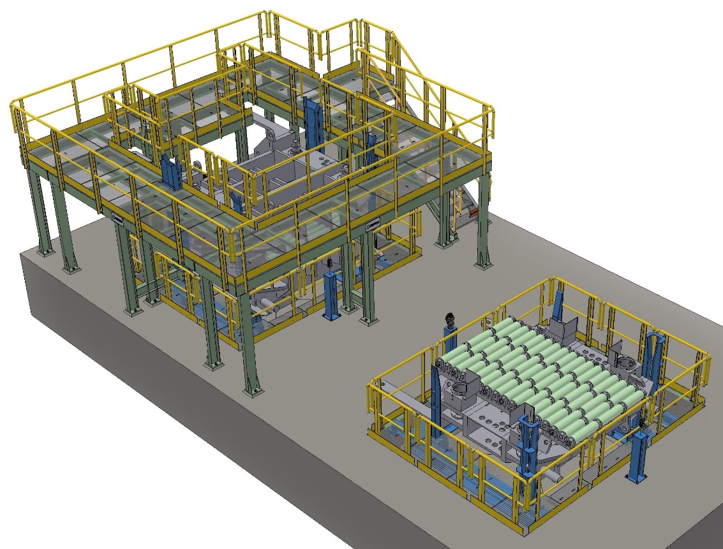

- Typical sketch for reference only –

CB.51.14 Segment alignment stand for entire segment (Existing)

Technical Data

|  |  |
| --- | --- |
| Stand capacity | 1 segment |
| Hydraulic supply | via hydraulic power unit for machine maintenance |

Functional Description

The stand serves to check the roller position, the frame structure for dimensional accuracy as well as internal machine cooling lines.

Tests carried out at the stand:

* Test of DynaGap adjustment (segment upper frame clamping)
* Test of driven roll screw down
* Tightness test for internal machine cooling line

Main Components

* Base frame with support brackets
* Centering guide
* Automatic connection of internal machine cooling line
* Reference measuring surfaces
* Platforms and stairs
* Straight ruler (only if OPAL is not installed!)  
  Note: use of rulers requires also INA-rails for ruler support and machined steel structure with supporting frame

Main Characteristics

* Reference supporting surfaces for simulation of supports in the machine
* Clear and easily accessible aligning stand
* An inspection pit made of concrete which is situated under the stand renders possible the access to the underside of the inner part of segments
* Less crane handling steps in case of leaking rollers since rollers can be exchanged right on this stand
* For conventional as well as SRD segments

Advantages of Design

* Easy and simple adjusting and checking with measuring device
* Measurement of roller alignment at any point over the full width possible
* Easy roller manipulation due to access from top
* Less handling steps

Reference Drawing CB.51.14 Segment alignment stand for entire segment

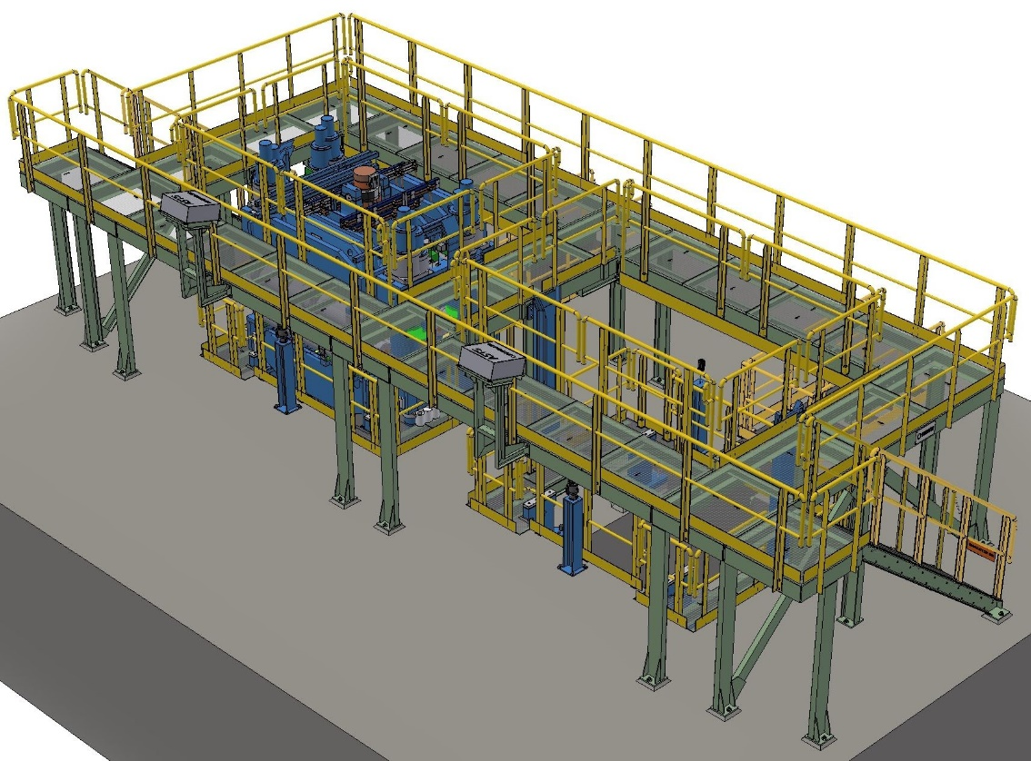

- Typical sketch for reference only –

CB.51.15 Segment alignment stand for inner bow (Existing)

Technical Data

|  |  |
| --- | --- |
| Stand capacity | 1 segment inner bow |

Functional Description

The segment inner bow alignment stand is used to store, maintain and align the top halve of the segment after it has been turned over on the segment inner bow turning stand.

Main Components

* Base frame with support brackets
* Centering guide
* Reference measuring surfaces
* Straight ruler (only if OPAL is not installed!)  
  Note: use of rulers requires also INA-rails for ruler support and machined steel structure with supporting frame

Main Characteristics

This stand will facilitate disassembly and reassemble of the rollers in the frame from the top. After reassembling the rollers in the top half of the segment, the rollers can be accurately aligned.

An inspection pit made of concrete which is situated under the stand renders possible the access to the underside of the inner part of segments.

Advantages of Design

* Easy and simple adjusting
* Measurement of roller alignment at any point over the full width possible
* Easy roller manipulation due to access from top
* Easy testing of machine cooling lines by use of hoses

Reference Drawing segment alignment stand for inner bow

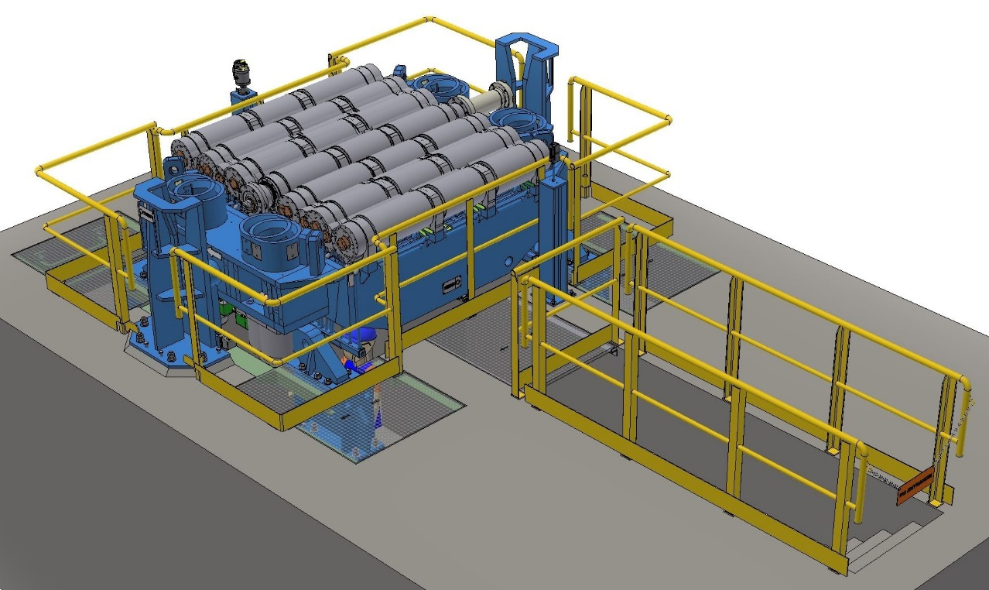

- Typical sketch for reference only –

CB.51.2 Storage- and handling stands

CB.51.21 Storage stand for DynaFlex oscillator

Technical Data

|  |  |
| --- | --- |
| Stand capacity | 1 Dynaflex oscillator unit |

Functional Description

The stand serves for storage and transporting of one oscillation unit.

Main Components

* Base frame
* Support and fixing screws

Reference Drawing CB.51.21 Storage Stand for Oscillator

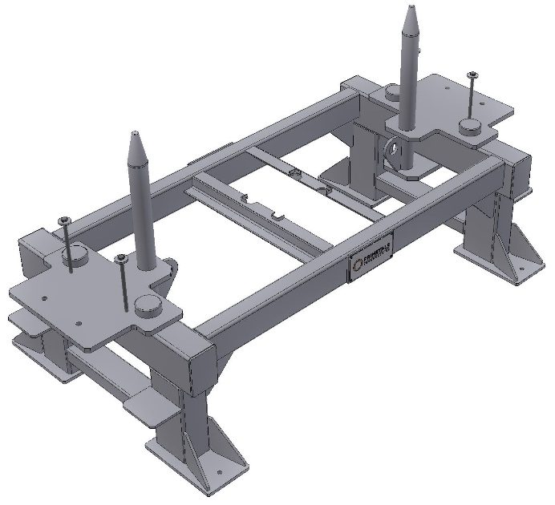

- Typical sketch for reference only –

CB.51.22 Storage stand for mold with bender

Technical Data

|  |  |
| --- | --- |
| Stand capacity | 1 set mold and bender |

Functional Description

The stand serves for storage of one mold and bender.

Main Components

* Platform and stairs
* Supports

Reference Drawing CB.51.22 Storage Stand for Mold with Bender

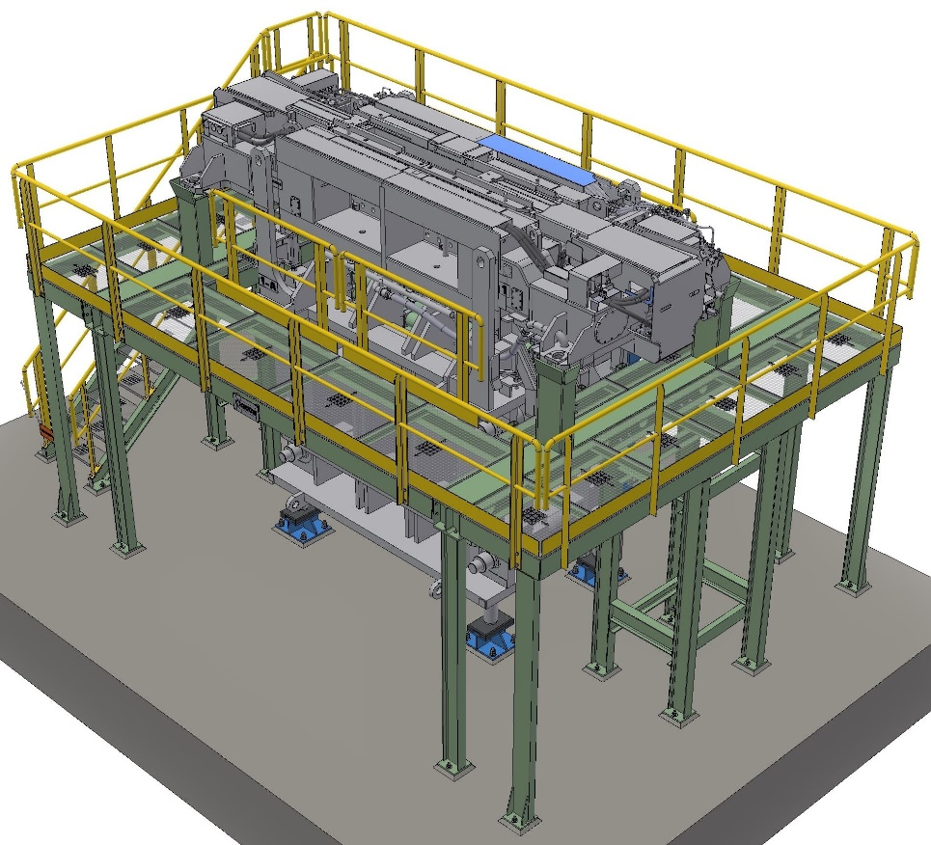

- Typical sketch for reference only –

CB.51.23 Bender turning stand (Existing)

Technical Data

|  |  |
| --- | --- |
| Stand capacity | 1 bender or bender inner bow |

Functional Description

The stand serves to turn over the bender and/or bender inner bow by crane and rope.

Main Components

* Supporting trestles
* Moveable supports

Description

The bender and/or bender inner bow is set up on the stand with the bender pivots on two forked like designed columns. For supporting bender and/or bender inner bow tilting and position moveable supports are used.

Reference Drawing CB.51.23 Bender turning stand

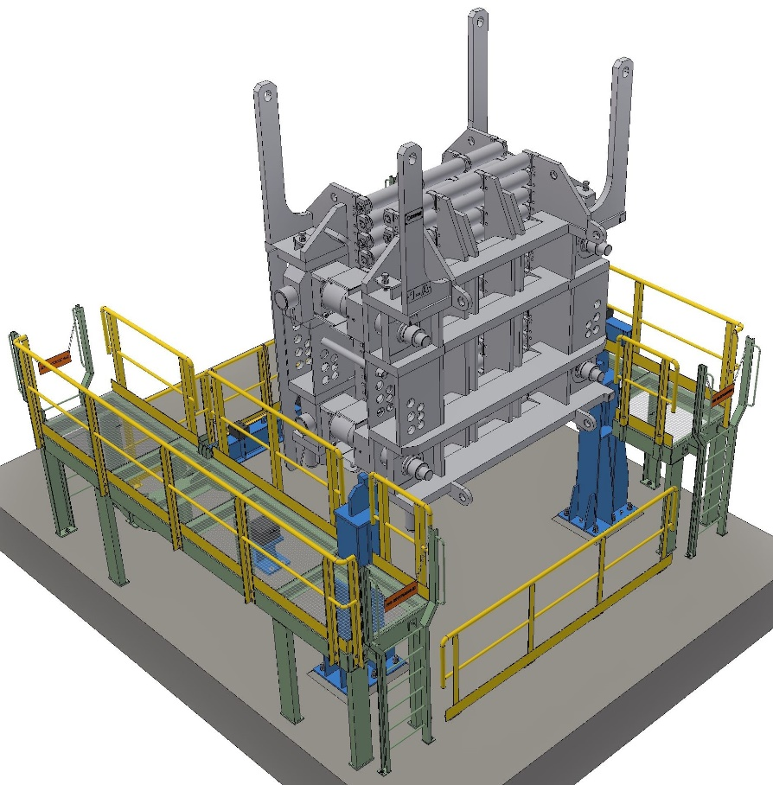

- Typical sketch for reference only –

CB.51.24 Segment inner bow turning stand (Existing)

Technical Data

|  |  |
| --- | --- |
| Stand capacity | 1 segment inner bow |
| Tilting range | 360° |
| Tilting drive | hydraulic |

Functional Description

The stand serves to turn over the segment inner bow by drive.

Main Components

* Supporting trestles
* Turning frame
* Tilting drive

Description

The segment inner bow is set up on the stand with the segment pivots on two columns. The one support is forked like designed only to support the segment. The other one has a turning unit.

The whole stand is surrounded by a safety fence with doors.

Reference Drawing CB.51.24 Segment inner bow turning stand

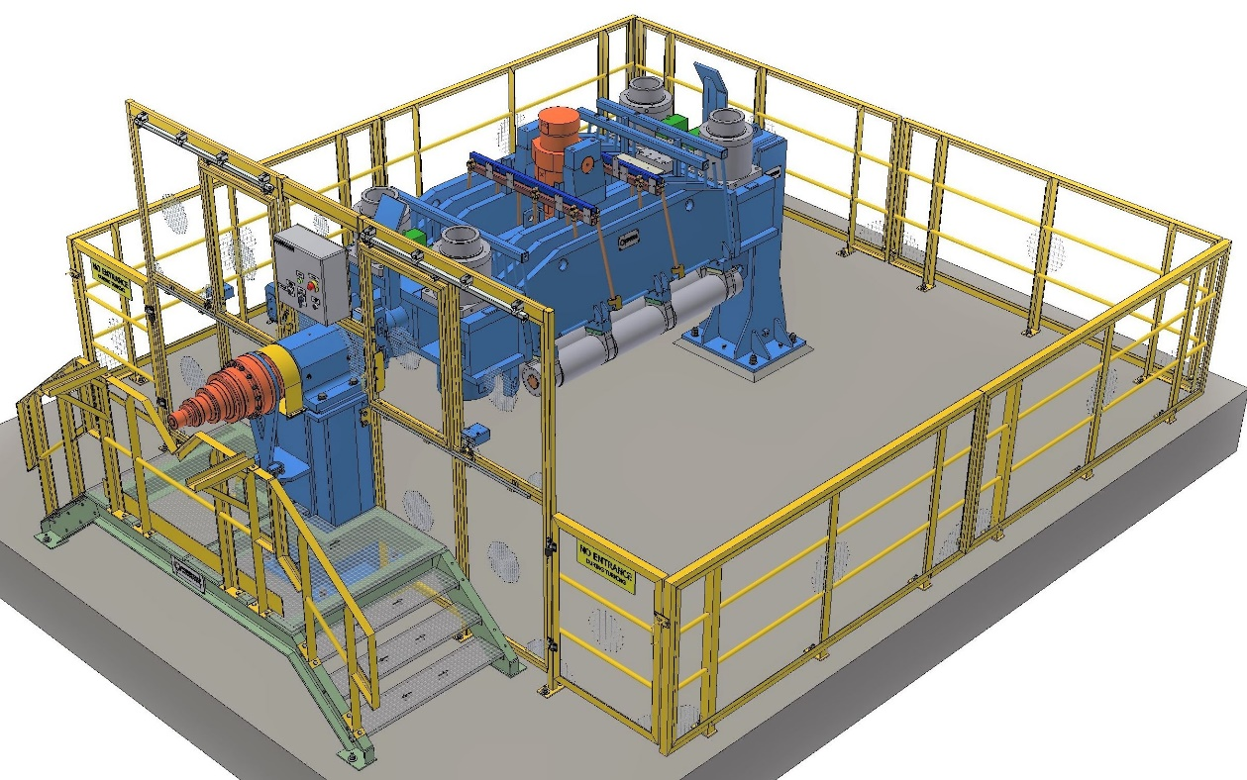

- Typical sketch for reference only -

CB.51.3 Water test stands

CB.51.31 Water test stand for bender and SRD type segment (Existing)

Technical Data

|  |  |
| --- | --- |
| Stand capacity | double stand for one (1) bender and one (1) segment (e.g. bow-, straightener- or horizontal segment) |
| Water supply | from service water system |
| Test pressure |  |
| spray test | max. 0.6 MPa |
| tightness test | max. …...MPa |
| Air supply | from utility compressed air system |

Functional Description

One stand is provided to check spray nozzles at bender.

The other stand is provided to check spray nozzles of bow, straightener and horizontal segments, as well as check of tightness of closed machine cooling.

Main Components

* Base frame
* Centering frame for bender and supporting and centering device for segments
* Water supply

Description

The bender is set up in working position on a centering frame.

When the bender and a segment are set up on the stand, the connection for water supply takes place after positioning of water connection elements.

The stand is surrounded with a concrete wall for spray water protection.

CB.51.31 Water test stand for bender and segment

Technical Data

|  |  |
| --- | --- |
| Stand capacity | quadruple stand for one (1) bender and one (1) segment (e.g. bow-, straightener- or horizontal segment) as well as one (1) bender inner bow and one (1) segment inner bow |
| Water supply | from service water system |
| Test pressure |  |
| spray test | max. 0.6 MPa |
| tightness test | max. …...MPa |
| Air supply | from utility compressed air system |

Functional Description

One stand is provided to check spray nozzles of complete bender unit and/or bender outer bow and one of bender inner bow.

The other stands are provided to check spray nozzles and closed machine cooling tightness of complete bow, straightener and horizontal segments and/or segment outer bows as well as one of segment inner bows.

Main Components

* Base frame
* Centering frame for bender or bender outer bow and bender inner bow and supporting and centering device for segments or segment outer bow and segment inner bow
* Bender outer bow turning stand
* Water supply

Description

The bender / segment and inner bows are set up in working position on a centering frame.

When the bender and a segment are set up on the stand, the connection for water supply takes place after positioning of water connection elements.

All stands are surrounded with a concrete wall for spray water protection.

Reference Drawing CB.51.31 Water test stand for bender and segment

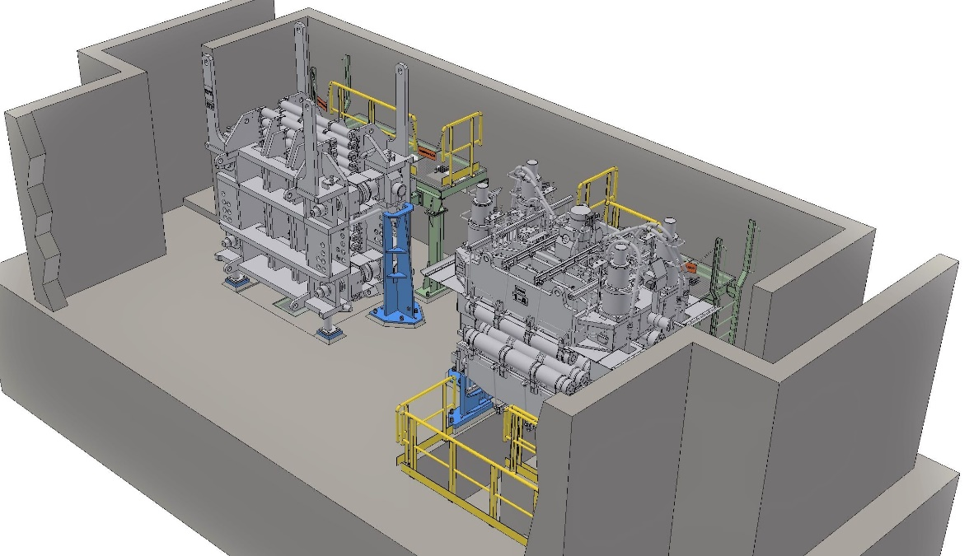

- Typical sketch for reference only -

CB.51.4 Assembly / disassembly stands

CB.51.41 Roller assembly / disassembly stand (Existing)

Technical Data

|  |  |
| --- | --- |
| Application | segment rollers |
| Roller type | all PT-roller types (I-Star and split roller) |
| Hydraulic supply | via hydraulic power unit for machine maintenance |

Functional Description

The through going roller axle is pushed out by means of a hydraulically adjusted ram, and the bearings and roller jackets are thus withdrawn one by one.

Main Components

* Frame
* Hydraulic cylinder with ram
* Assembly aids for different roller diameters
* Support for roller jacket
* Heating Device (Option)  
  NOTE: Engineering not available in-house > only available as packages (Engineering + Supply) from sub-suppliers (Messrs. Schabetsberger-mechanical portion / Messrs. IBEDA-gas portion)
* Protection cover (retractable)

Main Characteristics

* Automatic centering of roller jackets
* Suitability for different roller diameters by using assembly aids

Reference Drawing CB.51.41 Roller assembly / disassembly stand

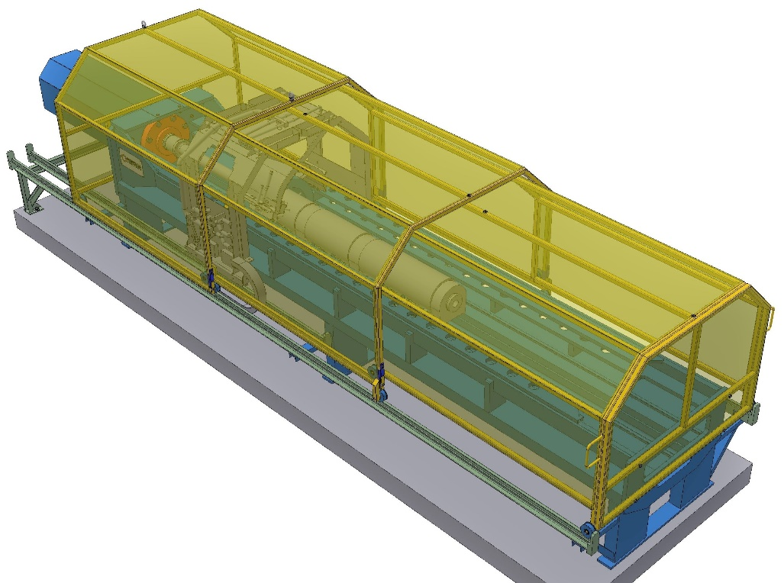

- Typical sketch for reference only -

CB.51.5 Transport units (OPTION)

CB.51.51 Transfer car (OPTION)

Technical Data

|  |  |
| --- | --- |
| Carrying capacity | xxx t |
| Traveling distance | xxx m |
| Traveling speed | 20.0 m/min. |
| Drive | electromechanical |
| Power supply | cable drum |

Functional Description

Track-bound transfer of machine components between machine and maintenance areas.

Main Components

* Loading platform
* Set of wheels
* Drive unit
* Cable drum
* Rails

Main Characteristics

* Automotive vehicle via cable power supply

CB.52. Measuring devices

CB.52.1 Mold measuring devices

CB.52.11A Taper measuring device (Existing)

Technical Data:

|  |  |
| --- | --- |
| Taper range | 0 - 25 mm/m |

Functional Description

The taper measuring device serves for careful check of the taper of the mold narrow sides to adjust them prior start of cast.

Main Components

* Measuring frame with adjusting unit and spirit level measuring planes
* Digital dial gauge

Reference Drawing CB.52.11A Taper measuring device

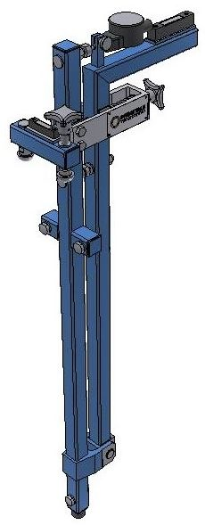

- Typical sketch for reference only –

CB.52.12 Measuring device for foot roller-bender (Existing)

Technical Data:

|  |  |
| --- | --- |
| Leveling range instrument | spirit level |

Functional Description

The alignment measuring device serves for accurate alignment of the mold foot rollers to the upper bender rollers in the plant. Correction of some misalignment can be carried out by moving the complete mold via adjustment bolts manually, if required.

Main Components

* Measuring frame with spirit level
* Contact planes with magnet

Reference Drawing CB.52.12 Measuring device for foot roll to bender

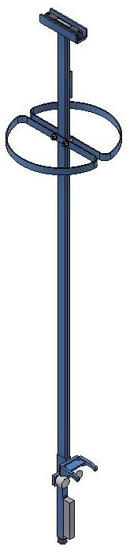

- Typical sketch for reference only -

CB.52.13 Transition ruler foot rollers / copper plates (Existing)

Technical Data:

|  |  |
| --- | --- |
| Staggered ruler | one for alignment check of mold copper plates to foot roller and copper plates to lateral foot rollers |

Reference Drawing CB.52.13 Transition ruler foot / copper plates

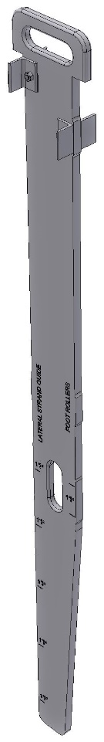

- Typical sketch for reference only -

CB.52.2 Strand guide measuring devices

CB.52.21 Transition rulers (Existing)

Technical Data:

|  |  |
| --- | --- |
| Templates | one for use of checking the transition between bender and bow,  one for use of checking the transition between bow segments,  one for use of checking the transition between bow and straightener segment #1.  one for use of checking the transition between straightener segments #1 and #2 |
| Straight ruler | one for use of checking the transition between straightener segment #2 and horizontal segment #1 and for check of transition between the horizontal segments |

CB.52.22 Strand Checker (Option)(OPTION)

Technical Data

|  |  |
| --- | --- |
| Type of construction | electromechanical operated roller gap measuring device with integrated data storage |
| Location | at the dummy bar, instead of dummy bar head |
| Casting thickness | basic equipment for main (one) casting thickness, additional measuring thickness possible (option) |
| Measuring range | Gap: ± 8 mm, Alignment: ± 5 mm |
| Measuring speed | 1…5 m/min (1…3 m/min during nozzle check) |
| Measuring accuracy | Gap: ± 0.1 mm, Alignment: ± 0.15 mm |
| Measuring direction | Top feeding: in casting direction, bottom feeding: in insert and casting direction |
| No. of measuring lines | 3 |
| Data acquisition: |  |
| gap measurement | by LVDT sensors |
| alignment | by LVDT sensors |
| roller rotation | by position encoders |
| spraywater check | by microphones |
| Data storage | flash memory module |
| Storage capacity | more than 50 measurements |
| Data evaluation | PC incl. operating system, monitor and printer (option) |

Functional Description

For measurement, the Strand Checker is driven through the plant along with the dummy bar and measures the gap, alignment, roll rotation and the spray water of the air mist nozzles. When the dummy bar exits the caster, data is automatically transferred to the evaluation PC. Afterwards, it can be analysed with the help of the analysing program.

Main Components

* Measuring head for casting thickness with adapter for dummy bar
* Electronics for Data recording and Data transfer (wireless)
* Evaluation Software
* Calibration device
* Pneumatic equipment for compensating roller clearance

Advantages of Design

* Direct DynaGap connection
* no data transfer errors
* fast and reliable calibration of DynaGap segments
* No LVDT sensors on lower side of Strand Checker
* rolls that are not exactly opposite can be measured easier
* fewer sensors required of complete measurement
* sensors on lower side may be damaged easier through contact with ground
* Pneumatic springs
* easy insert and exit of Strand Checker
* very high and nearly constant forces by pneumatic springs

Typical Design

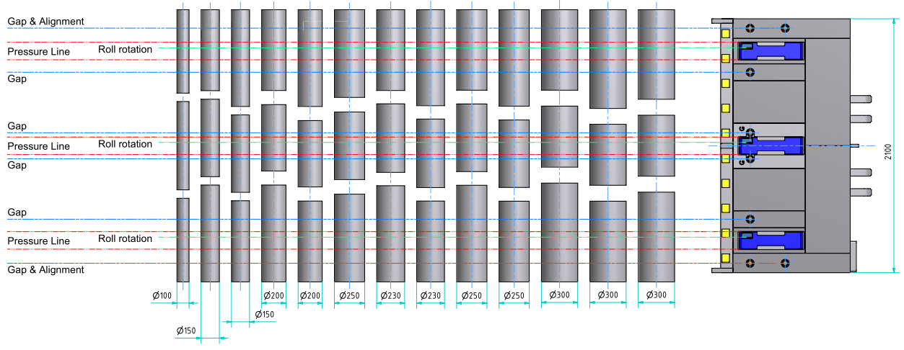

- Typical sketch for reference only -

CB.52.23 Gap Checker – (Manual roll gap checker) (Existing)

The Gap Checker is used to measure the gap between individual rolls in the strand containment.

Technical Data

|  |  |
| --- | --- |
| Type of construction | Digital Gauge with a measurement range of 12.5mm |
| Measurement range | 65 – 125mm (Gap Checker Special)  130 – 180mm (Gap Checker Mini)  180 – 500mm (Gap Checker Maxi) |
| Calibration | With digital caliper and calibration base |

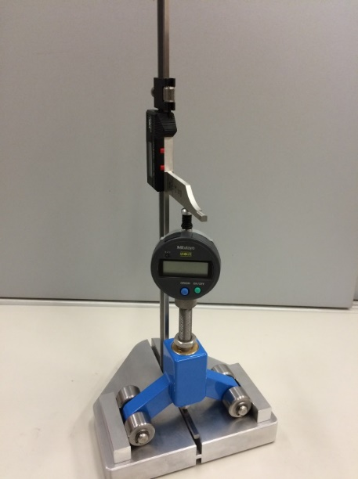

- Typical sketch for reference only –

CB.52.25 Roller alignment device OPAL (Existing)

Technical Data

|  |  |
| --- | --- |
| Laser protection class | 2 |
| Resolution of Measurement | 0,01 mm |
| Measurement accuracy | ±0,07 mm |

Functional Description

The alignment device serves for measuring the deviation of the strand guide rollers to a defined reference. With the result of the measurement the bearing support of each roller can be shimmed.

Main Components

* Laser Source
* Laser Receiver for Stabilization of the Laser Surface
* Laser Receiver with Bluetooth
* Handheld PC with Bluetooth and Opal Software

Main Characteristics

* High Precise Laser Alignment Device with Bluetooth Interface
* Opal Software for evaluation and Condition monitoring

Advantage of Design

* Easy Handling
* Quick measurement
* Automatic generated Test Report
* Perfect positioning of Strand Guide Rollers
* Electronic Data Management system

CB.53. Tundish preparation

Existing facilities will be used

CB.53.1 Tundish tilting device

CB.53.11 Tundish tilting stand

Technical Data

|  |  |
| --- | --- |
| Capacity | 1 full tundish |
| Tilting range | 180° |
| Tilting drive | hydraulic |

Functional Description

After insertion and fixing in the tilting stand, the tundish is hydraulically tilted.  
Refractory lining and the remaining skulls are dropped out in this tilting stand.  
The stand sits on a concrete base.

Main Components

* Supporting frame
* Support bracets
* Tilting drive
* Hydraulic pusher for remaining skull

Reference Drawing CB.53.11 Tundish tilting stand

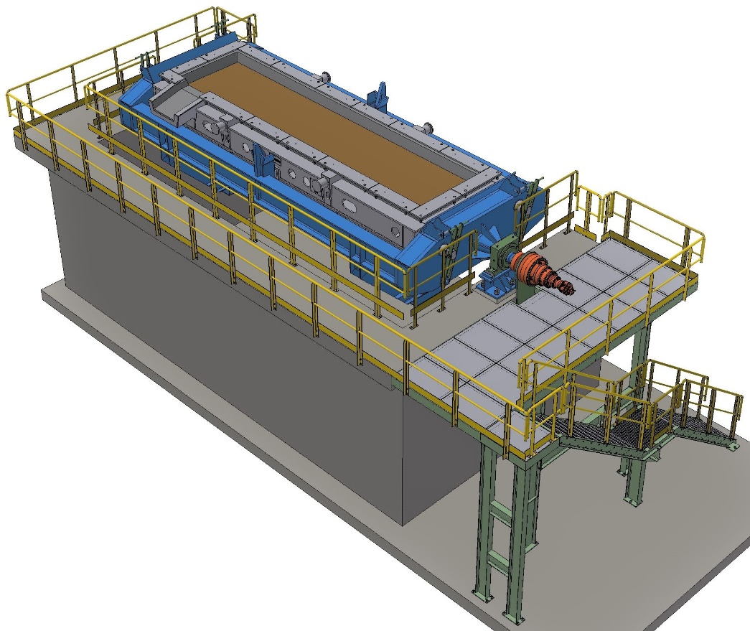

- Typical sketch for reference only -

CB.53.13 Tundish tilting stand housing

Technical Data

|  |  |
| --- | --- |
| Capacity | 1 tundish tilting stand |

Functional Description

Serves to keep dust inside during dropping of refractory lining and remaining skulls on the tilting stand.

Main Components

* Housing around tilting stand with doors, shifting roof and connection to an exhaust system

CB.53.2 Tundish stands

CB.53.21 Tundish assembly / disassembly stand

Technical Data

|  |  |
| --- | --- |
| Type of construction | steel structure and supporting foundations |
| Capacity | 1 tundish |

Functional Description

This stand provides assembly and disassembly of tundish covers, tundish stopper device from platform level and assembly and disassembly of emergency cut off gate, SEN changer, slide gate from ground floor level.

Main Components

* Concrete foundation (tundish support)
* Steel structure platform with stairs

Reference Drawing CB.53.2 Tundish stands

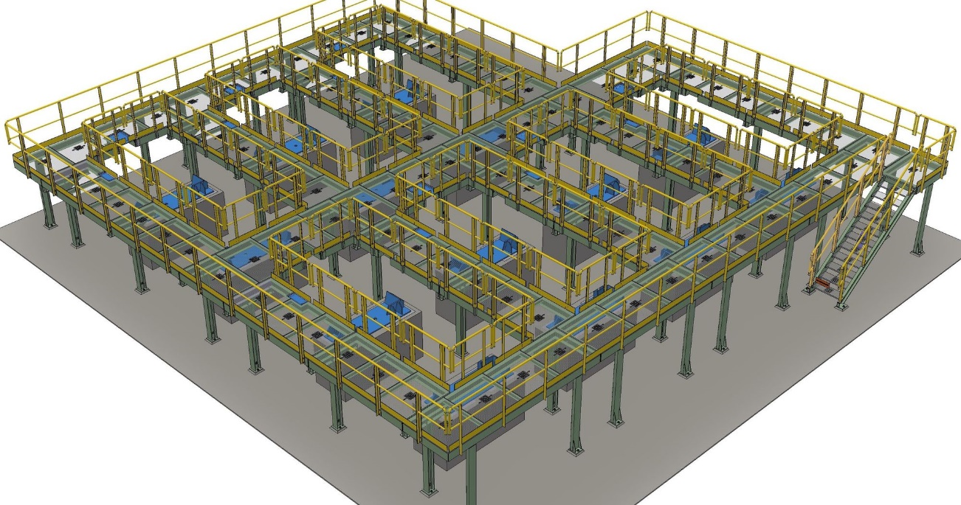

- Typical sketch for reference only -

CB.53.22 Tundish relining stand

Technical Data

|  |  |
| --- | --- |
| Type of construction | Tundish support brackets with moveable platform |
| Capacity | 1 tundish |

Functional Description

The tundish is placed on support brackets. A moveable platform provides access to the tundish for relining of the permanent lining.

Main Components

* Moveable platform
* Support brackets

CB.53.23 Tundish gunning stand

Technical Data

|  |  |
| --- | --- |
| Type of construction | Tundish support brackets with moveable platform |
| Capacity | 1 tundish |

Functional Description

The tundish is placed on support brackets. A moveable platform provides access to the tundish to carry out work of the wear lining.

Main Components

* Moveable platform
* Support brackets

CB.53.24 Tundish storage stand

Technical Data

|  |  |
| --- | --- |
| Type of construction | Concrete yard |
| Capacity | 1 tundish |

Functional Description

Area for storage of ready tundishes, before transport to caster.

CB.53.3 Tundish cooling devices

CB.53.31 Tundish cooling stand

Technical Data

|  |  |
| --- | --- |
| Type of construction | Tundish support brackets |
| Capacity | 1 tundish |

Functional Description

The tundish is placed on support brackets for cooling down.

Main Components

* Support brackets

CB.53.32 Tundish cooling fan

Technical Data

|  |  |
| --- | --- |
| No. of Cooling Fans | 2 |
| Type of fan | portable on floor |
| Capacity | 25000 m³/h approx. |
| pressure | 250 Pa approx. |
| material | galvanized |

Functional Description

Slag and remaining steel in the tundish as well as the tundish lining are cooled with air.

Main Components

* Cooling air fan

CB.53.4 Tundish drying devices

CB.53.41 Tundish drying stand

Technical Data

|  |  |
| --- | --- |
| Type of construction | Tundish support brackets |
| Capacity | 1 tundish |

Functional Description

The tundish is placed on support brackets for drying purposes.

Main Components

* Support brackets

CB.53.42 Tundish drying station

Technical Data

|  |  |
| --- | --- |
| Heating capacity | max. 800 kW (2 Strand 🡪 1200 kW) |
| No. of burners | 2 (2 Strand 🡪 3) |
| Fuel gas | natural gas to check Alt. coke oven gas / LPG |
| Combustion air | by air fan |
| Tundish preheating temperature | max. 800 °C |
| Drying time |  |
| for wear lining | approx. 150 min …*) |
| for permanent lining | approx. 120 hours …*) |
|  | *)…final drying time and procedure to be defined by the Buyer or refractory material supplier |

Technical Description:

|  |  |
| --- | --- |
| Type of design | package unit, controlled via local control panel |
| Ignition of burners | automatic incl. flame detection |
| Tilting drive | hydraulically |
| Burner control | automatic by programmable temperature controller |

Main Components

* Supporting structure
* Tilting frame
* Gas burners
* Heat protection covering
* Combustion air fan
* Gas / air control station
* Nitrogen flushing system (for coke oven gas only !)
* Hydraulic tilting drive
* Hydraulic power unit
* Electrical control panel

CB.53.5 Flow control maintenance devices

CB.53.55 Stopper rod trestle

Technical Data

|  |  |
| --- | --- |
| Type of Design | steel structure |
| Capacity of Storage Trestle | 6 stopper systems |

Technical Description:

The stopper rod trestle serves for storage of the complete stopper rod systems.

CB.53.6 Tundish relining equipment

refer to scope list.

CB.53.7 Tundish gunning equipment

refer to scope list.

CB.53.9 Tundish auxiliaries & building

refer to scope list.

CB.54. Suspensions

CB.54.1 Beam suspensions

CB.54.11 Tundish beam suspension (Existing)

Technical Data

Application

For handling of

* Tundish trough

Carrying capacity limited to 1 full tundish trough

Functional Description

The beam suspensions allow for the transfer of the above components.

Main Components

* Beams
* Hooks

Advantages of Design

* Suspension can be placed on the ground without storage stand

Reference Drawing CB.54.11 Tundish beam suspension

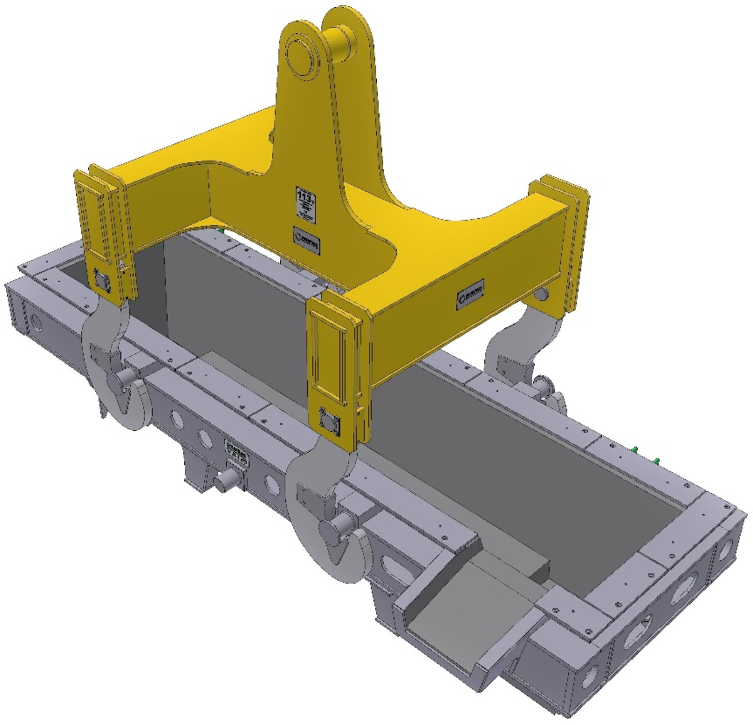

- Typical sketch for reference only -

CB.54.12A Universal beam suspension casting area

Technical Data

Application

For handling of

* Mold cover
* Removable cover for casting platform
* Mold
* Bender
* Mold together with bender

Carrying capacity limited to 1 mold and 1 bender together with stuck slab

Functional Description

The combined beam suspension with chains allows for the transfer of the above components using only one suspension.

Main Components

* Beam
* Chains with suspensions

Main Characteristics

* Uniform load distribution onto the chains
* Transfer of different components using the same chain due to special chain design
* Low overall height of the suspension

Advantages of Design

* Time is saved because the suspension need not be exchanged (minimization of empty crane running)
* Suspension can be placed on the ground without storage stand

Reference Drawing CB.54.12A Universal beam suspension casting area

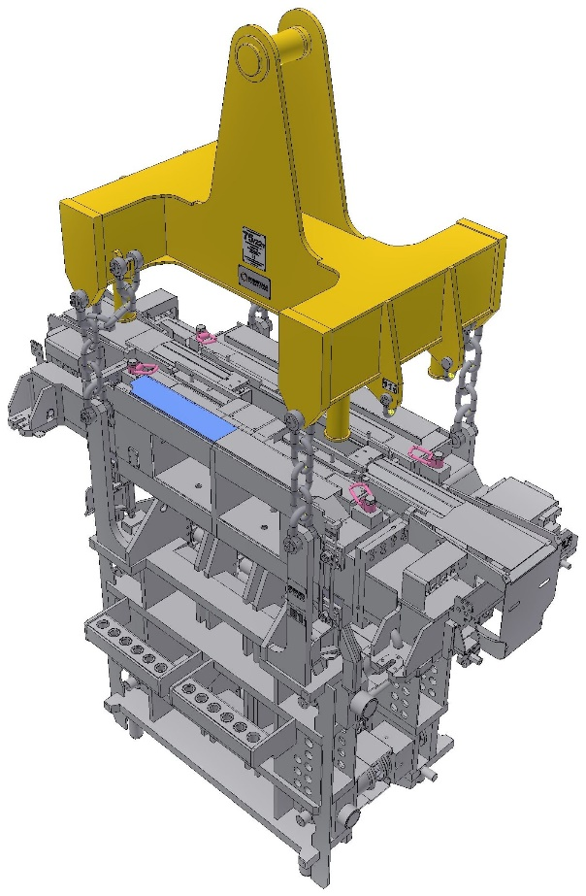

- Typical sketch for reference only -

CB.54.2 Rope / Chain suspensions

Technical Data

Application

Transfer of

* Tundish cover (if existing)
* Mold and bender separately
* Mold cover
* Segment
* Dummy bar head
* Coverings and buckets
* Oscillation unit
* Dummy bar

Carrying capacity limited to 1 piece of each

CB.54.3 Storage stands for beam suspensions (OPTION)

Application

Storage of:

* Segment Manipulator (existing reused)
* Tundish Beam suspension (existing reused)

CB.54.4 Storage stands for rope/chain suspensions

Application

Storage of:

* Rope suspension casting floor
* Rope suspension maintenance area

Reference Drawing CB.54.4 Storage stands for rope/chain suspensions

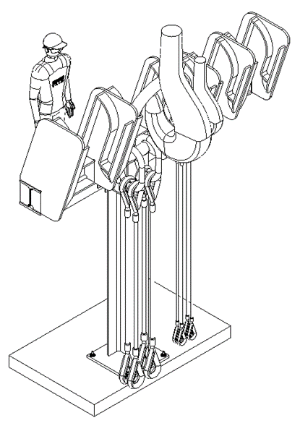

-Typical sketch for reference only-

CB.55. Ancillary facilities

CB.55.1 Standard tools

|  |  |
| --- | --- |
| Torque wrench | Nm: 5 – 50, 20 – 200, 140 – 750, 750 – 2000, 1500 – 3000 |
| Hook wrench | B 80 – 90, B 120 – 130 acc. to DIN 1810 |
| Single-head engineers jaw wrench, resp. screw wrench |  |
| Width across flats: | S55, S65, S75 |
| Inside micrometer | 50 – 450 mm |
| Lifting jack with hand pump (e.g. Enerpac) | RC 102 (10 t), RCA 304 (30 t) and hand pump |
| Straight ruler | 2000 mm DIN 874/I |

CB.55.2 Special tools

CB.55.21 Hydraulic bolt tensioning cylinder for ladle turret

To tighten and proof the foundation bolts and connection bolts between foundation frame swivelling bearing and rotating body and the connection between rotating body and lever brackets.

CB.55.22 Make shifts for ladle turret

Makeshifts are used for mounting and dismounting of arms, cylinders and bearings.

Main components

* Suspension chain
* Puller
* Supporting columns
* Removal device for bearing assembly and disassembly

CB.55.23 Torque wrench for segment fixation

Electrical torque wrench with angle design

CB.55.24 Tie rode tensioning device for bender and segments

Hydraulic bolt tensioning device for tie rode tensioning M100 x 4 including electric high pressure pump

CB.55.3 Tools for casting operation

Including:

* SEN handling tongs
* Dummy bar head sealing tool
* Mold powder pusher
* Mold narrow side protection plates
* Slag ‘fishing’ rods and removal device

Final list of tools for casting operation will be provided in the Caster Operation Manuals.

CB.55.4 Assembly device for erection

These are fabricated steel devices used to ensure accurate alignment of the strand guide equipment including segment support structure and segment guide rails. The devices are used during equipment erection.

CB.56. Scale handling

Scale and cutting debris will be collected in the caster flume and transported to the scale pit by open system water. Scale removal from the scale pit will typically be by over-head grab crane.

CB.57. Refractory material and other consumables

Refer to scope list

CB.6 Maintenance and Store

Buyer’s scope.

CB. 7 Infrastructure and Auxiliaries

CB.71 Building and Foundation

Caster Rooms

Below the casting platform necessary rooms for water system, hydraulic and electric systems are located.

Embedded Steel Parts

|  |  |  |
| --- | --- | --- |
| Material:： |  | Steel |

Main Components

* Casting floor embedded steel parts (Buyer’s scope)
* Ladle turret embedded frame (Buyer’s scope)
* Oscillation embedded unit
* Segment guide rails embedded parts
* Foundation bolts
* Borderings, welding bases, railings
* Trench covers
* Flume lining steel
* Runout embedded parts
* Maintenance embedded parts
* Tundish preparation embedded parts (Buyer’s scope)

The embedded steel parts are embedded into various concrete foundations and serve for fixation of various machine parts of the continuous casting plant to the foundation.

Intellectual Property Rights and Confidentiality

|  |
| --- |
| This document contains valuable trade secrets and confidential information of Primetals Technologies and the content of this document is and shall remain the intellectual property right of Primetals Technologies. Any recipient shall keep this document and all its contents strictly confidential, not disclose it or any part thereof to any third party without Primetals Technologies' prior written consent and not use any information, specification or data contained in this document for purposes other than for the evaluation of this document.  No part of this document is allowed to be adapted, copied, reproduced, duplicated, translated into another language, distributed or processed (print, photocopy, microfilm or any other process), neither by the use of electronic systems nor otherwise without the prior written permission of Primetals Technologies.  Any recipient shall limit access to this document and to any part thereof to those of its employees reasonably required being aware thereof and shall ensure their strict adherence to the provisions of confidentiality and restriction of use as expressed above.  Any violation of the above provisions will be brought before the competent court in accordance with the applicable law. |

Revision History

|  |  |  |
| --- | --- | --- |
| Revision | Date | Changes |
| Rev 0 | October 2021 | Initial Offer |